|  |
| --- |
|  |
| |  |  |  | | --- | --- | --- | | 75 | Date: | February 2015 | |
| ADL and AML Non-normative Examples    Version: 1.0  **OMG Document Number: health/2014-10-01**  **Standard document URL: http://www.omg.org/spec/AML/1.0**  Original File: N/A |

# AML and ADL Examples

The following section gives examples of AML and their ADL equivalents to illustrate the relationship between ADL and AML. These are valid OpenEHR ADL archetypes that have been converted into AML.

## AOM Structures Basic Examples

### Mixed AOM Node Types v1 Example

Test various AOM C\_OBJECT types together, to ensure co-existence within the same object structure.

#### Mixed AOM Node Types v1 ADL

EVALUATION[id1] matches { -- Evaluation

data matches {

ITEM\_TREE[id14] matches {

items matches {

CLUSTER[id2] matches { -- cluster

items matches {

use\_node ELEMENT[id10] /data[id14]/items[id11]/items[id13] -- /data[id14]/items[cluster]/items[element]

allow\_archetype CLUSTER[id4] matches { -- element

include

archetype\_id/value matches {/.\*/}

}

ELEMENT[id3] -- element

}

}

CLUSTER[id11] matches { -- cluster

items matches {

ELEMENT[id13] -- element

}

}

}

}

}

}

#### Mixed AOM Node Types v1 ADL Diagram

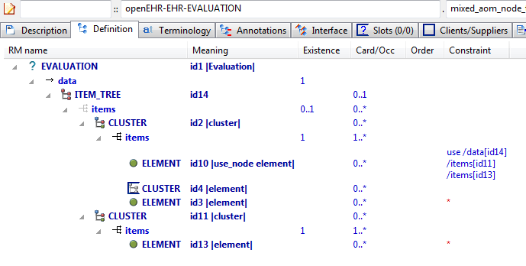

#### Mixed AOM Node Types v1 AML Diagram

NeuroMax:Users:patrick:git-opencimi:AML:adl-examples-for-aml:examples:aom_structures:basic:openEHR-EHR-EVALUATION.mixed_aom_node_types.v1.adls.pdf

### Structure Test1 v1 Example

Demonstrate simple RM structure hierarchy in an archetype.

#### Structure Test1 v1 ADL

BOOK[id1] matches { -- Work of fiction

title matches {"Devils"}

author matches {"Fyodor Dostoyevsky"}

chapters matches {

CHAPTER[id2] matches { -- 1st chapter of the book

title matches {"By way of introduction"}

}

CHAPTER[id3] matches { -- 2nd chapter of the book

title matches {"Prince Harry, matchmaking"}

}

CHAPTER[id4] matches { -- 3rd chapter of the book

title matches {"Another man's sins"}

}

}

}

#### Structure Test1 v1 ADL Diagram

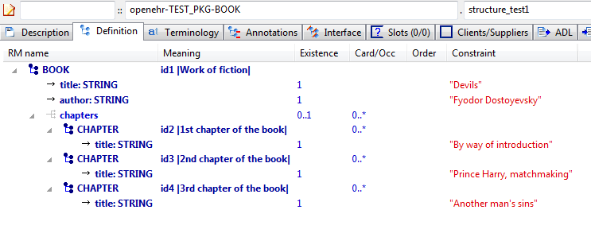

#### Structure Test1 v1 AML Diagram

### Assumed Values Example

Test constraints on primitive types that have added 'assumed values' as defined by the AOM

#### Assumed Values ADL

WHOLE[id1] matches { -- test entry

string\_attr1 matches {"something", "something else"; "something else"}

string\_attr2 matches {/this|that|something else/; "this"}

string\_attr3 matches {/cardio.\*/; "cardiology examination"}

boolean\_attr1 matches {True}

boolean\_attr2 matches {False}

boolean\_attr3 matches {True, False; True}

integer\_attr1 matches {55}

integer\_attr2 matches {10, 20, 30; 10}

integer\_attr3 matches {|0..100|; 10}

integer\_attr4 matches {|>10|; 11}

integer\_attr5 matches {|<10|; 9}

integer\_attr6 matches {|>=10|; 10}

integer\_attr7 matches {|<=10|; 5}

integer\_attr8 matches {|-10..-5|; -8}

integer\_attr9 matches {10}

real\_attr1 matches {100.0}

real\_attr2 matches {10.0, 20.0, 30.0; 20.0}

real\_attr3 matches {|0.0..100.0|; 20.4}

real\_attr4 matches {|>=10.0|; 20.0}

real\_attr5 matches {|<=10.0|; 9.5}

real\_attr6 matches {|>=10.0|; 20.3}

real\_attr7 matches {|<=10.0|; 8.0}

real\_attr8 matches {|-10.0..-5.0|; -9.8}

real\_attr9 matches {10.0}

date\_attr1 matches {yyyy-mm-dd; 1995-03-17}

date\_attr2 matches {yyyy-??-??; 1995-03-17}

date\_attr3 matches {yyyy-mm-??; 1995-03-17}

date\_attr4 matches {yyyy-??-XX; 1995-03}

date\_attr5 matches {1983-12-25}

date\_attr6 matches {2000-01-01}

time\_attr1 matches {hh:mm:ss; 12:01:30}

time\_attr2 matches {hh:mm:XX; 12:01}

time\_attr3 matches {hh:??:XX; 12:00}

time\_attr4 matches {hh:??:??; 12:00}

time\_attr5 matches {22:00:05,0}

time\_attr6 matches {00:00:59,0}

time\_attr7 matches {00:00:59,0}

date\_time\_attr1 matches {yyyy-mm-ddThh:mm:ss; 1995-03-17T12:01:30}

date\_time\_attr2 matches {yyyy-mm-ddThh:mm:??; 1995-03-17T12:01}

date\_time\_attr3 matches {yyyy-mm-ddThh:mm:XX; 1995-03-17T12:01}

date\_time\_attr4 matches {yyyy-mm-ddThh:??:XX; 1995-03-17T12:01}

date\_time\_attr5 matches {yyyy-??-??T??:??:??; 1995-03-17T12:01}

date\_time\_attr6 matches {1983-12-25T22:00:05,0}

date\_time\_attr7 matches {2000-01-01T00:00:59,0}

date\_time\_attr8 matches {2000-01-01T00:00:59,0}

duration\_attr1 matches {PT0S}

duration\_attr2 matches {P1D}

duration\_attr3 matches {PT2H5M}

duration\_attr4 matches {PT1H55M}

duration\_attr5 matches {|<=PT1H|; PT30M}

duration\_attr6 matches {PT1H30M}

}

#### Assumed Values ADL Diagram

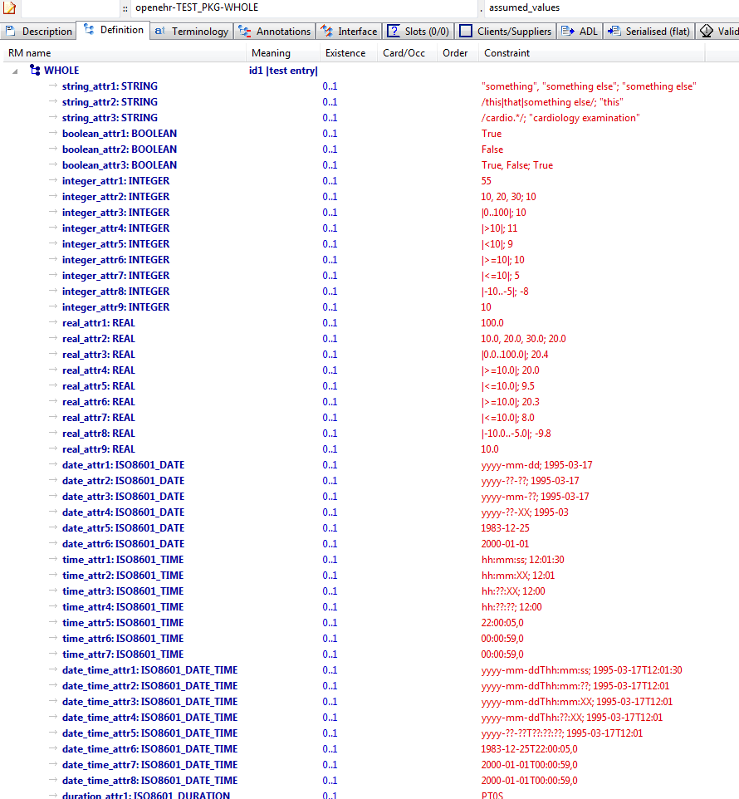

#### Assumed Values AML Diagram

### Most Minimal v1 Example

#### Most Minimal v1 ADL

WHOLE[id1] -- most minimal

#### Most Minimal v1 ADL Diagram

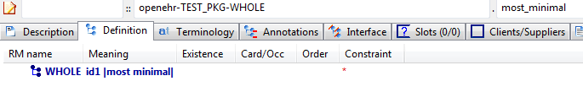

#### Most Minimal v1 AML Diagram

### Most Minimal v2 Example

Test what happens when a different major version (v2) of an existing archetype is encountered by tools. The tool should treat this archteype as distinct from other major versions of this archetype.

#### Most Minimal v2 ADL

WHOLE[id1] -- most minimal

#### Most Minimal v2 ADL Diagram

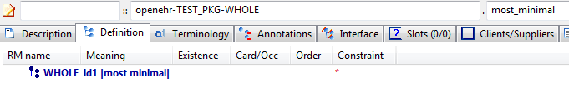

#### Most Minimal v2 AML Diagram

### Most Minimal v3 Example

Test what happens when a different major version (v3) of an existing archetype is encountered by tools. The tool should treat this archteype as distinct from other major versions of this archetype.

#### Most Minimal v3 ADL

WHOLE[id1] -- most minimal

#### Most Minimal v3 ADL Diagram

#### Most Minimal v3 AML Diagram

### Primitive Types Example

Test constraints on built-in types assumed by ADL / AOM. These types include:

#### Primitive Types ADL

WHOLE[id1] matches { -- test entry

string\_attr1 matches {"something"}

string\_attr2 matches {/this|that|something else/}

string\_attr3 matches {/cardio.\*/}

string\_attr4

string\_attr5 matches {"and", "something", "else"}

boolean\_attr1 matches {True}

boolean\_attr2 matches {False}

boolean\_attr3 matches {True, False}

boolean\_attr4

integer\_attr1 matches {55}

integer\_attr2 matches {10, 20, 30}

integer\_attr3 matches {|0..100|}

integer\_attr4 matches {|>0..100|}

integer\_attr5 matches {|0..<100|}

integer\_attr6 matches {|>0..<100|}

integer\_attr7 matches {|>10|}

integer\_attr8 matches {|<10|}

integer\_attr9 matches {|>=10|}

integer\_attr10 matches {|<=10|}

integer\_attr11 matches {|-10..-5|}

integer\_attr12 matches {10}

integer\_attr13

real\_attr1 matches {100.0}

real\_attr2 matches {10.0, 20.0, 30.0}

real\_attr3 matches {|0.0..100.0|}

real\_attr4 matches {|>0.0..100.0|}

real\_attr5 matches {|0.0..<100.0|}

real\_attr6 matches {|>0.0..<100.0|}

real\_attr7 matches {|>=10.0|}

real\_attr8 matches {|<=10.0|}

real\_attr9 matches {|>=10.0|}

real\_attr10 matches {|<=10.0|}

real\_attr11 matches {|-10.0..-5.0|}

real\_attr12 matches {10.0}

real\_attr13

date\_attr1 matches {yyyy-mm-dd}

date\_attr2 matches {yyyy-??-??}

date\_attr3 matches {yyyy-mm-??}

date\_attr4 matches {yyyy-??-XX}

date\_attr5 matches {1983-12-25}

date\_attr6 matches {2000-01-01}

date\_attr7 matches {2000-01-01}

date\_attr8 matches {|2000-01-01..2000-02-01|}

date\_attr9 matches {|>2000-01-01..2000-02-01|}

date\_attr10 matches {|2000-01-01..<2000-02-01|}

date\_attr11 matches {|>2000-01-01..<2000-02-01|}

time\_attr1 matches {hh:mm:ss}

time\_attr2 matches {hh:mm:??}

time\_attr3 matches {hh:mm:XX}

time\_attr4 matches {hh:??:??}

time\_attr5 matches {hh:??:XX}

time\_attr6 matches {22:00:05,0}

time\_attr7 matches {00:00:59,0}

time\_attr8 matches {00:00:59,0}

time\_attr9 matches {|01:00:00..02:00:00|}

time\_attr10 matches {|>01:00:00..02:00:00|}

time\_attr11 matches {|01:00:00..<02:00:00|}

time\_attr12 matches {|>01:00:00..<02:00:00|}

date\_time\_attr1 matches {yyyy-mm-ddThh:mm:ss}

date\_time\_attr2 matches {yyyy-mm-ddThh:mm:??}

date\_time\_attr3 matches {yyyy-mm-ddThh:mm:XX}

date\_time\_attr4 matches {yyyy-mm-ddThh:??:??}

date\_time\_attr5 matches {yyyy-mm-ddThh:??:XX}

date\_time\_attr6 matches {yyyy-??-??T??:??:??}

date\_time\_attr7 matches {1983-12-25T22:00:05,0}

date\_time\_attr8 matches {2000-01-01T00:00:59,0}

date\_time\_attr9 matches {2000-01-01T00:00:59,0}

date\_time\_attr10 matches {|2000-01-01T01:00:00..2000-01-01T02:00:00|}

date\_time\_attr11 matches {|>2000-01-01T01:00:00..2000-01-01T02:00:00|}

date\_time\_attr12 matches {|2000-01-01T01:00:00..<2000-01-01T02:00:00|}

date\_time\_attr13 matches {|>2000-01-01T01:00:00..<2000-01-01T02:00:00|}

duration\_attr1 matches {Pw}

duration\_attr2 matches {Pmw}

duration\_attr3 matches {PWD}

duration\_attr4 matches {PD}

duration\_attr5 matches {Pym}

duration\_attr6 matches {PdThms}

duration\_attr7 matches {PTs}

duration\_attr8 matches {PThm}

duration\_attr9 matches {PT0S}

duration\_attr10 matches {PT0S}

duration\_attr11 matches {P1D}

duration\_attr12 matches {|P38W..P39W4D|}

duration\_attr13 matches {|>P38W..P39W4D|}

duration\_attr14 matches {|P38W..<P39W4D|}

duration\_attr15 matches {|>P38W..<P39W4D|}

duration\_attr16 matches {PT2H5M}

duration\_attr17 matches {PT1H55M}

duration\_attr18 matches {|<=PT1H|}

duration\_attr19 matches {PT1H30M}

duration\_attr20 matches {Pw/PT0S}

duration\_attr21 matches {Pmw/PT0S}

duration\_attr22 matches {PWD/PT0S}

duration\_attr23 matches {PD/PT0S}

duration\_attr24 matches {Pym/PT0S}

duration\_attr25 matches {PdThms/PT0S}

duration\_attr26 matches {PTs/PT0S}

duration\_attr27 matches {PThm/PT0S}

duration\_attr28 matches {Pw/|P38W..P39W4D|}

duration\_attr29 matches {Pmw/|P38W..P39W4D|}

duration\_attr30 matches {PWD/|P38W..P39W4D|}

duration\_attr31 matches {PD/|P38W..P39W4D|}

duration\_attr32 matches {Pym/|P38W..P39W4D|}

duration\_attr33 matches {PdThms/|P38W..P39W4D|}

duration\_attr34 matches {PTs/|P38W..P39W4D|}

duration\_attr35 matches {PThm/|P38W..P39W4D|}

duration\_attr36 matches {|>=PT0S|}

}

#### Primitive Types ADL Diagram

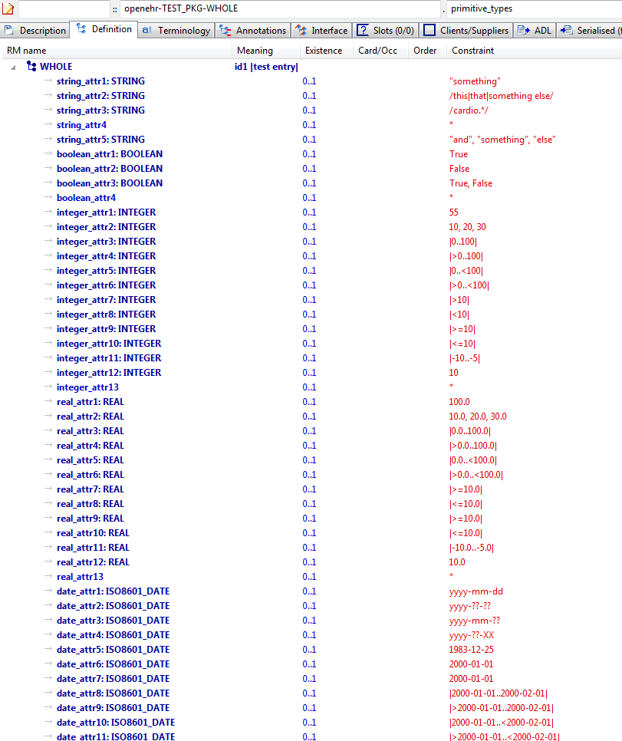

#### Primitive Types AML Diagram

## AOM Structures C\_attribute\_alternatives Examples

### Quantity Alternatives Example

Demonstrate multiple alternative Quantity expressions.

#### Quantity Alternatives ADL

CLUSTER[id1] matches { -- Ambient oxygen

items matches {

ELEMENT[id52] occurrences matches {0..1} matches { -- Oxygen flow rate

value matches {

DV\_QUANTITY[id55] matches {

property matches {[at1]}

[magnitude, units, precision] matches {

[{|0.0..50.0|}, {"l/m"}, {1}],

[{|0.0..50000.0|}, {"ml/min"}, {1}]

}

}

}

}

ELEMENT[id54] occurrences matches {0..1} matches { -- un

value matches {

DV\_PROPORTION[id56] matches {

numerator matches {|0.0..1.0|; 0.21}

is\_integral matches {False}

type matches {1}

}

DV\_PROPORTION[id57] matches {

numerator matches {|0.0..100.0|; 21.0}

is\_integral matches {False}

type matches {2}

}

}

}

ELEMENT[id55] occurrences matches {0..1} matches { -- un

value matches {

DV\_PROPORTION[id58] matches {

[numerator, is\_integral, type] matches

{[{|0.0..1.0|; 0.21}, {False}, {1}],

[{|0.0..100.0|; 21.0}, {False}, {2}]}

}

}

}

}

}

#### Quantity Alternatives ADL Diagram

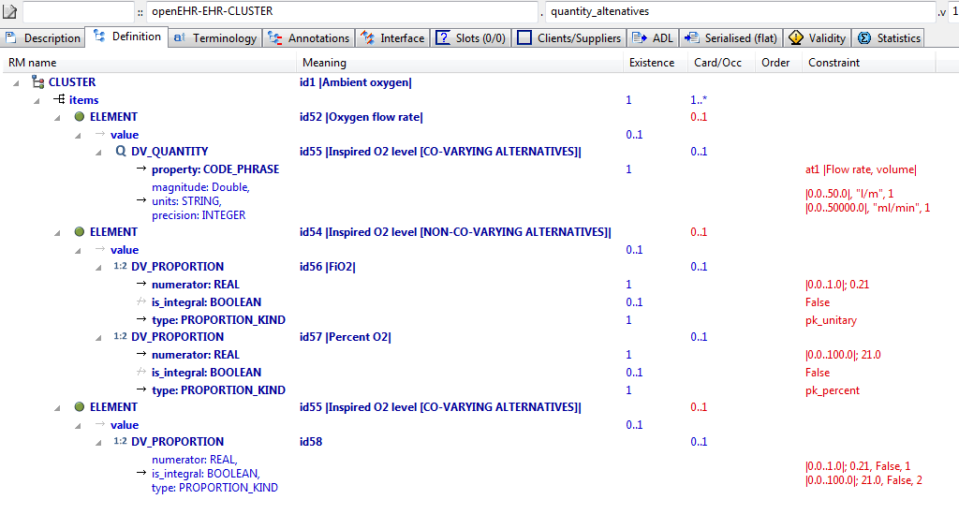

#### Quantity Alternatives AML Diagram

### Multiple Alternatives Example

Test multiple alternative nodes of single-valued attribute; view in flat mode to see result

#### Multiple Alternatives ADL

OBSERVATION[id1] matches { -- top-level archetype

protocol matches {

ITEM\_TREE[id2] -- protocol #1

ITEM\_TREE[id3] -- protocol #2

}

}

#### Multiple Alternatives ADL Diagram

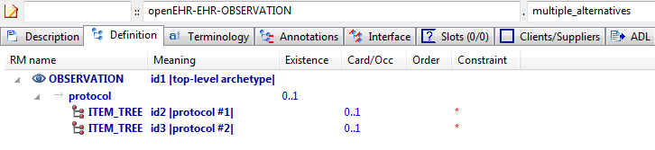

#### Multiple Alternatives AML Diagram

## AOM Structures Rules Examples

### Rules Formulae v1 Example

Illustrate rules that define formulae based on archetype data points. This example defines two rules based on well known blood pressure formulae, viz 'mean arterial pressure' and 'pulse pressure'. These both use

#### Rules Formulae v1 ADL

OBSERVATION[id1] matches { -- Blood Pressure

data matches {

HISTORY[id2] matches { -- history

events cardinality matches {1..\*; unordered} matches {

EVENT[id7] occurrences matches {0..\*} matches { -- any event

data matches {

ITEM\_TREE[id4] matches {

items matches {

ELEMENT[id5] occurrences matches {0..1} matches { -- Systolic

value matches {

DV\_QUANTITY[id1054] matches {

property matches {[at1055]}

magnitude matches {|0.0..<1000.0|}

units matches {"mm[Hg]"}

precision matches {0}

}

}

}

ELEMENT[id6] occurrences matches {0..1} matches { -- Diastolic

value matches {

DV\_QUANTITY[id1055] matches {

property matches {[at1055]}

magnitude matches {|0.0..<1000.0|}

units matches {"mm[Hg]"}

precision matches {0}

}

}

}

ELEMENT[id1007] occurrences matches {0..1} matches { -- Mean Arterial Pressure

value matches {

DV\_QUANTITY[id1056] matches {

property matches {[at1055]}

magnitude matches {|0.0..<1000.0|}

units matches {"mm[Hg]"}

precision matches {0}

}

}

}

ELEMENT[id1008] occurrences matches {0..1} matches { -- Pulse Pressure

value matches {

DV\_QUANTITY[id1057] matches {

property matches {[at1055]}

magnitude matches {|0.0..<1000.0|}

units matches {"mm[Hg]"}

precision matches {0}

}

}

}

ELEMENT[id34] occurrences matches {0..1} matches { -- Comment

value matches {

DV\_TEXT[id1058]

}

}

}

}

}

state matches {

ITEM\_TREE[id8] matches {

items matches {

ELEMENT[id9] occurrences matches {0..1} matches { -- Position

value matches {

DV\_CODED\_TEXT[id1059] matches {

defining\_code matches {[ac1; at1002]} -- Position

}

}

}

ELEMENT[id1053] occurrences matches {0..1} matches { -- Confounding factors

value matches {

DV\_TEXT[id1060]

}

}

allow\_archetype CLUSTER[id1031] occurrences matches {0..1} matches { -- Exertion

include

archetype\_id/value matches {/openEHR-EHR-CLUSTER\.level\_of\_exertion(-a-zA-Z0-9\_]+)\*\.v1/}

}

ELEMENT[id1044] occurrences matches {0..1} matches { -- Sleep status

value matches {

DV\_CODED\_TEXT[id1061] matches {

defining\_code matches {[ac2; at1045]} -- Sleep status

}

}

}

ELEMENT[id1006] occurrences matches {0..1} matches { -- Tilt

value matches {

DV\_QUANTITY[id1062] matches {

property matches {[at1059]}

magnitude matches {|-90.0..90.0|}

units matches {"°"}

precision matches {0}

}

}

}

}

}

}

}

INTERVAL\_EVENT[id1043] occurrences matches {0..1} matches { -- 24 hour average

math\_function matches {

DV\_CODED\_TEXT[id1063] matches {

defining\_code matches {[at1060]}

}

}

width matches {

DV\_DURATION[id1064] matches {

value matches {PT24H}

}

}

data matches {

use\_node ITEM\_TREE[id1065] /data[id2]/events[id7]/data[id4] -- /data[history]/events[any event]/data[id4]

}

state matches {

use\_node ITEM\_TREE[id1066] /data[id2]/events[id7]/state[id8] -- /data[history]/events[any event]/state[id8]

}

}

}

}

}

protocol matches {

ITEM\_TREE[id12] matches { -- list structure

items matches {

ELEMENT[id14] occurrences matches {0..1} matches { -- Cuff size

value matches {

DV\_CODED\_TEXT[id1067] matches {

defining\_code matches {[ac3]} -- Cuff size

}

}

}

CLUSTER[id1034] occurrences matches {0..1} matches { -- Location

items matches {

ELEMENT[id15] occurrences matches {0..1} matches { -- Location of measurement

value matches {

DV\_CODED\_TEXT[id1068] matches {

defining\_code matches {[ac4]} -- Location of measurement

}

}

}

ELEMENT[id1035] occurrences matches {0..1} matches { -- Specific location

value matches {

DV\_TEXT[id1069]

}

}

}

}

ELEMENT[id1036] occurrences matches {0..1} matches { -- Method

value matches {

DV\_CODED\_TEXT[id1070] matches {

defining\_code matches {[ac5]} -- Method

}

}

}

ELEMENT[id1039] occurrences matches {0..1} matches { -- Mean Arterial Pressure Formula

value matches {

DV\_TEXT[id1071]

}

}

ELEMENT[id1011] occurrences matches {0..1} matches { -- Diastolic endpoint

value matches {

DV\_CODED\_TEXT[id1072] matches {

defining\_code matches {[ac6]} -- Diastolic endpoint

}

}

}

allow\_archetype CLUSTER[id1026] occurrences matches {0..1} matches { -- Device

include

archetype\_id/value matches {/openEHR-EHR-CLUSTER\.device([a-zA-Z0-9\_]+)\*\.v1/}

}

}

}

}

}

rules

mean\_arterial\_pressure: /data[id2]/events[id7]/data[id4]/items[id1007]/value/magnitude = /data[id2]/events[id7]/data[id4]/items[id6]/value/magnitude + 0.33 \* (/data[id2]/events[id7]/data[id4]/items[id5]/value/magnitude - /data[id2]/events[id7]/data[id4]/items[id6]/value/magnitude)

pulse\_pressure: /data[id2]/events[id7]/data[id4]/items[id1008]/value/magnitude = /data[id2]/events[id7]/data[id4]/items[id5]/value/magnitude - /data[id2]/events[id7]/data[id4]/items[id6]/value/magnitude

#### Rules Formulae v1 ADL Diagram

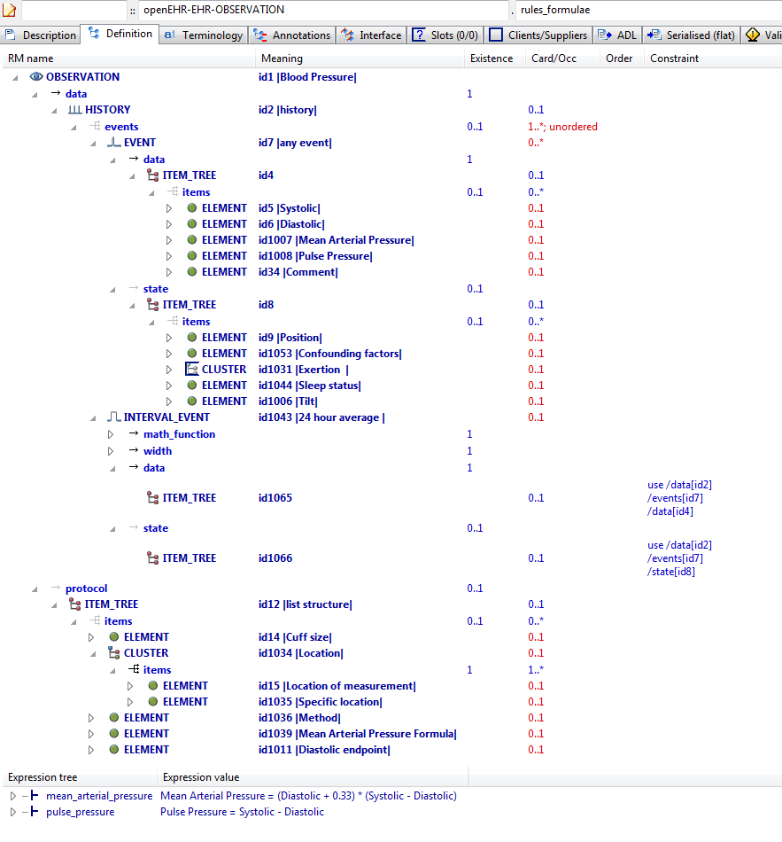

#### Rules Formulae v1 AML Diagram

## AOM Structures Slots Examples

### Slot Include Any Exclude Empty v1 Example

Demonstrate 'open' slot.

#### Slot Include Any Exclude Empty v1 ADL

SECTION[id1] matches { -- Slot section

items cardinality matches {1..\*; unordered} matches {

allow\_archetype OBSERVATION[id2] occurrences matches {0..1} matches { -- Vital signs

include

archetype\_id/value matches {/.\*/}

}

}

}

#### Slot Include Any Exclude Empty v1 ADL Diagram

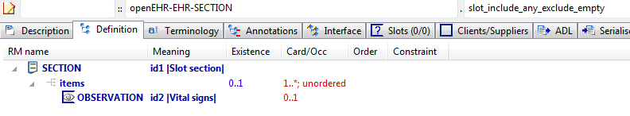

#### Slot Include Any Exclude Empty v1 AML Diagram

NeuroMax:Users:patrick:git-opencimi:AML:adl-examples-for-aml:aml_diagrams:openEHR-EHR-SECTION.slot_include_any_exclude_empty.v1.pdf

### Slot Include Any Exclude Non Any v1 Example

Test slot with any include and non-any exclude, which corresponds to 'hard' exclusion.

#### Slot Include Any Exclude Non Any v1 ADL

SECTION[id1] matches { -- Slot section

items cardinality matches {1..\*; unordered} matches {

allow\_archetype OBSERVATION[id2] occurrences matches {0..1} matches { -- Vital signs

include

archetype\_id/value matches {/.\*/}

exclude

archetype\_id/value matches {/openEHR-EHR-OBSERVATION\.blood\_pressure([a-zA-Z0-9\_]+)\*\.v1/}

}

}

}

#### Slot Include Any Exclude Non Any v1 ADL Diagram

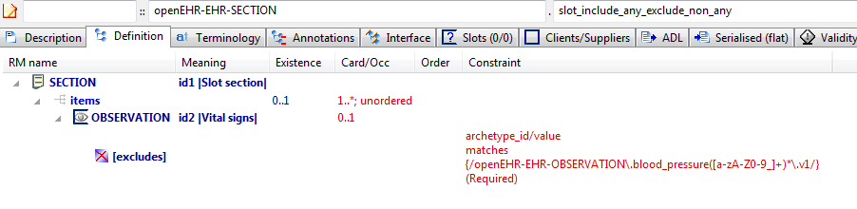

#### Slot Include Any Exclude Non Any v1 AML Diagram

NeuroMax:Users:patrick:git-opencimi:AML:adl-examples-for-aml:aml_diagrams:openEHR-EHR-SECTION.slot_include_any_exclude_non_any.v1.pdf

### Slot Include Empty Exclude Any v1 Example

Test slot with no include and exclude = any

#### Slot Include Empty Exclude Any v1 ADL

SECTION[id1] matches { -- Slot section

items cardinality matches {1..\*; unordered} matches {

allow\_archetype OBSERVATION[id2] occurrences matches {0..1} matches { -- Vital signs

exclude

archetype\_id/value matches {/.\*/}

}

}

}

#### Slot Include Empty Exclude Any v1 ADL Diagram

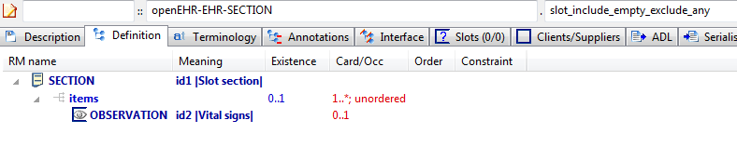

#### Slot Include Empty Exclude Any v1 AML Diagram

NeuroMax:Users:patrick:git-opencimi:AML:adl-examples-for-aml:aml_diagrams:openEHR-EHR-SECTION.slot_include_empty_exclude_any.v1.pdf

### Slot Include Empty Exclude Empty v1 Example

Test slot with no include or exclude

#### Slot Include Empty Exclude Empty v1 ADL

SECTION[id1] matches { -- Slot section

items cardinality matches {1..\*; unordered} matches {

allow\_archetype OBSERVATION[id2] occurrences matches {0..1} -- Vital signs

}

}

#### Slot Include Empty Exclude Empty v1 ADL Diagram

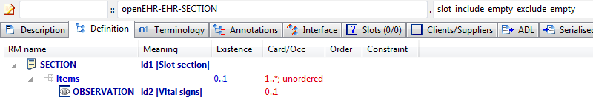

#### Slot Include Empty Exclude Empty v1 AML Diagram

NeuroMax:Users:patrick:git-opencimi:AML:adl-examples-for-aml:aml_diagrams:openEHR-EHR-SECTION.slot_include_empty_exclude_empty.v1.pdf

### Slot Include Empty Exclude Non Any v1 Example

Slot with no include and non-any exclude, which defines a recommendation to exclude.

#### Slot Include Empty Exclude Non Any v1 ADL

SECTION[id1] matches { -- Slot section

items cardinality matches {1..\*; unordered} matches {

allow\_archetype OBSERVATION[id2] occurrences matches {0..1} matches { -- Vital signs

exclude

archetype\_id/value matches {/openEHR-EHR-OBSERVATION\.blood\_pressure([a-zA-Z0-9\_]+)\*\.v1/}

}

}

}

#### Slot Include Empty Exclude Non Any v1 ADL Diagram

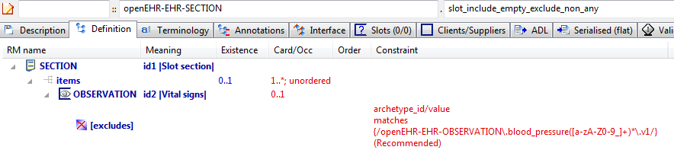

#### Slot Include Empty Exclude Non Any v1 AML Diagram

NeuroMax:Users:patrick:git-opencimi:AML:adl-examples-for-aml:aml_diagrams:openEHR-EHR-SECTION.slot_include_empty_exclude_non_any.v1.pdf

### Slot Include Non Any Exclude Any v1 Example

Test slot archetype with non-any include and exclude = any, which corresponds to 'hard' includes.

#### Slot Include Non Any Exclude Any v1 ADL

SECTION[id1] matches { -- Slot section

items cardinality matches {1..\*; unordered} matches {

allow\_archetype OBSERVATION[id2] occurrences matches {0..1} matches { -- Vital signs

include

archetype\_id/value matches {/openEHR-EHR-OBSERVATION\.blood\_pressure([a-zA-Z0-9\_]+)\*\.v1/}

exclude

archetype\_id/value matches {/.\*/}

}

}

}

#### Slot Include Non Any Exclude Any v1 ADL Diagram

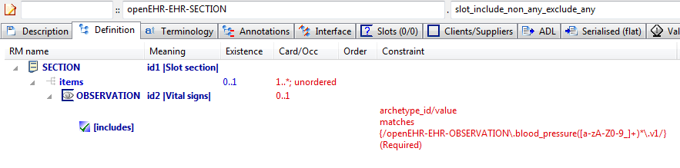

#### Slot Include Non Any Exclude Any v1 AML Diagram

NeuroMax:Users:patrick:git-opencimi:AML:adl-examples-for-aml:aml_diagrams:openEHR-EHR-SECTION.slot_include_non_any_exclude_any.v1.pdf

### Slot Include Non Any Exclude Empty v1 Example

Archetype with non-any include and no excludes, which means the includes are taken as recommendations.

#### Slot Include Non Any Exclude Empty v1 ADL

SECTION[id1] matches { -- Slot section

items cardinality matches {1..\*; unordered} matches {

allow\_archetype OBSERVATION[id2] occurrences matches {0..1} matches { -- Vital signs

include

archetype\_id/value matches {/openEHR-EHR-OBSERVATION\.blood\_pressure([a-zA-Z0-9\_]+)\*\.v1|openEHR-EHR-OBSERVATION\.body\_temperature([a-zA-Z0-9\_]+)\*\.v1|openEHR-EHR-OBSERVATION\.heart\_rate([a-zA-Z0-9\_]+)\*\.v1|openEHR-EHR-OBSERVATION\.indirect\_oximetry([a-zA-Z0-9\_]+)\*\.v1|openEHR-EHR-OBSERVATION\.respiration([a-zA-Z0-9\_]+)\*\.v1/}

}

}

}

#### Slot Include Non Any Exclude Empty v1 ADL Diagram

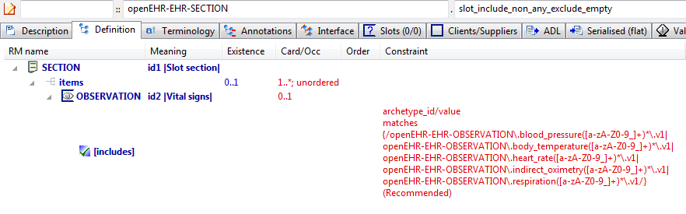

#### Slot Include Non Any Exclude Empty v1 AML Diagram

NeuroMax:Users:patrick:git-opencimi:AML:adl-examples-for-aml:aml_diagrams:openEHR-EHR-SECTION.slot_include_non_any_exclude_empty.v1.pdf

## AOM Structures Tuples Examples

### Real Ordinal v1.0.0 Example

Test integer ordinal values for an RM that has ORDINAL.value defined as Real; constraints should silently be promoted to Reals.

#### Real Ordinal v1.0.0 ADL

ITEM\_GROUP[id1] matches { -- Laboratory test ordinal

item matches {

ELEMENT[id2] matches { -- Result value

value matches {

ORDINAL[id3] matches {

[symbol, value] matches {

[{[at1]}, {0.0}],

[{[at2]}, {1.0}],

[{[at3]}, {2.0}]

}

}

}

}

}

}

#### Real Ordinal v1.0.0 ADL Diagram

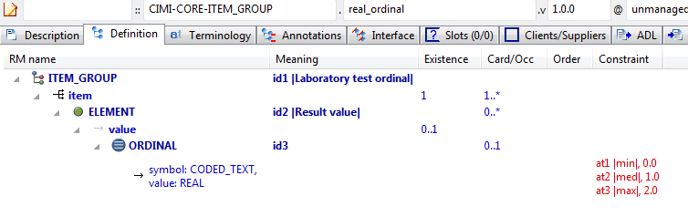

#### Real Ordinal v1.0.0 AML Diagram

### Ordinal Tuple v1 Example

Example of a tuple used to model an 'ordinal' reference model concept. The latter is one in which there is logically a 2-column list of {value, symbol} pairs (the value is typically an Integer). The tuple constraint provides a nice way to model this, by limiting the possible pairs (mostly meaningless) to just those that make sense in the domain.

#### Ordinal Tuple v1 ADL

OBSERVATION[id1] matches { -- Apgar score

data matches {

HISTORY[id3] matches {

events cardinality matches {1..\*; unordered} matches {

POINT\_EVENT[id4] occurrences matches {0..1} matches { -- 1 minute

data matches {

ITEM\_LIST[id2] matches {

items cardinality matches {1..6; ordered} matches {

ELEMENT[id10] occurrences matches {0..1} matches { -- Respiratory effort

value matches {

DV\_ORDINAL[id11] matches {

[value, symbol] matches {

[{0}, {[at11]}],

[{1}, {[at12]}],

[{2}, {[at13]}]

}

}

}

}

}

}

}

}

}

}

}

}

#### Ordinal Tuple v1 ADL Diagram

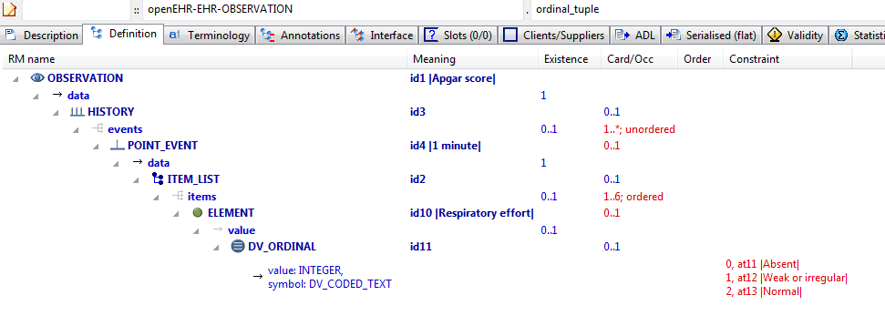

#### Ordinal Tuple v1 AML Diagram

### Dv Ordinals v1 Example

Example showing openEHR DV\_ORDINAL modelled with and without tuples.

#### Dv Ordinals v1 ADL

SOME\_TYPE[id1] matches { -- root item

standard\_ordinal\_attr matches {

DV\_ORDINAL[id5] matches { -- ordinal 1

value matches {0}

symbol matches {

DV\_CODED\_TEXT[id8] matches {

defining\_code matches {[at2]}

}

}

}

DV\_ORDINAL[id6] matches { -- ordinal 2

value matches {1}

symbol matches {

DV\_CODED\_TEXT[id9] matches {

defining\_code matches {[at3]}

}

}

}

DV\_ORDINAL[id7] matches { -- ordinal 3

value matches {2}

symbol matches {

DV\_CODED\_TEXT[id10] matches {

defining\_code matches {[at4]}

}

}

}

}

clinical\_ordinal\_attr\_1 matches {

DV\_ORDINAL[id11] matches {

[value, symbol] matches {

[{0}, {[at2]}],

[{1}, {[at3]}],

[{2}, {[at4]}]

}

}

}

}

#### Dv Ordinals v1 ADL Diagram

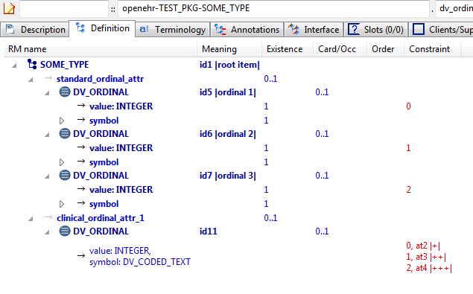

#### Dv Ordinals v1 AML Diagram

### Dv Quantity Tuple v1 Example

Illustrates DV\_QUANTITY tuple constraints

#### Dv Quantity Tuple v1 ADL

SOME\_TYPE[id1] matches { -- root item

clinical\_quantity\_attr\_1 matches {

DV\_QUANTITY[id2] matches {

property matches {[at1]}

[units, magnitude] matches {

[{"C"}, {|>=4.0|}],

[{"F"}, {|>=40.0|}]

}

}

}

}

#### Dv Quantity Tuple v1 ADL Diagram

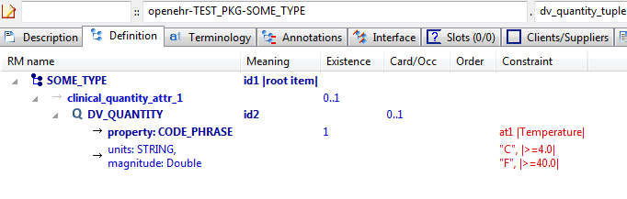

#### Dv Quantity Tuple v1 AML Diagram

## AOM Structures Use\_archetype Examples

### Ext Ref v1 Example

Example of an external reference, expressed using the 'use\_archetype' keyword. This defines a direct association between the archetypes, without the need for a slot, and a corresponding association (which may be an aggregation or composition) of Reference Model structures. The constraint below says concretely that the COMPOSITION object contains SECTION and OBSERVATION objects under its content attribute.

#### Ext Ref v1 ADL

COMPOSITION[id1] matches { -- Composition

content matches {

use\_archetype SECTION[id2, openEHR-EHR-SECTION.section\_parent.v1] occurrences matches {0..1}

use\_archetype OBSERVATION[id3, openEHR-EHR-OBSERVATION.spec\_test\_obs.v1] occurrences matches {1}

}

}

#### Ext Ref v1 ADL Diagram

#### Ext Ref v1 AML Diagram

NeuroMax:Users:patrick:git-opencimi:AML:adl-examples-for-aml:aml_diagrams:openEHR-EHR-COMPOSITION.ext_ref.v1.pdf

## AOM Structures Use\_node Examples

### Use Node Occurrences v1 Example

Example showing override of occurrences at source end of use\_node. With no occurrences stated on a use\_node node, the occurrences at target of the reference are used. This can be overridden as in this example with an occurrences at the source end.

#### Use Node Occurrences v1 ADL

PERSON[id1] matches { -- person demographics

contacts matches {

CONTACT[id6] matches { -- home contact

addresses matches {

ADDRESS[id7] occurrences matches {0..1} -- home phone number

ADDRESS[id8] occurrences matches {0..2} -- home fax number

ADDRESS[id9] -- home email address

}

}

CONTACT[id10] matches { -- work contact

addresses matches {

use\_node ADDRESS[id11] /contacts[id6]/addresses[id7] -- /contacts[home contact]/addresses[home phone number]

use\_node ADDRESS[id12] /contacts[id6]/addresses[id8] -- /contacts[home contact]/addresses[home fax number]

use\_node ADDRESS[id13] occurrences matches {1..3} /contacts[id6]/addresses[id9] -- /contacts[home contact]/addresses[home email address]

}

}

}

}

#### Use Node Occurrences v1 ADL Diagram

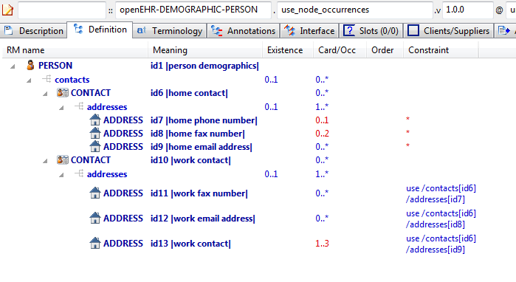

#### Use Node Occurrences v1 AML Diagram

### Path Analysis Use Nodes v1 Example

Illustrate path set created by multiple use\_node references. Three paths should be visible that end in [id14] in the path analysis.

#### Path Analysis Use Nodes v1 ADL

OBSERVATION[id1] matches { -- Laboratory result

data matches {

HISTORY[id2] matches {

events cardinality matches {1..\*; unordered} matches {

EVENT[id3] occurrences matches {0..\*} matches { -- Any event

data matches {

ITEM\_TREE[id4] matches {

items matches {

CLUSTER[id12] matches { -- level 1

name matches {

DV\_CODED\_TEXT[id23] matches {

defining\_code matches {[ac1]} -- =LOINC::Battery\_name

}

}

items matches {

CLUSTER[id13] matches { -- level 2

name matches {

DV\_CODED\_TEXT[id24] matches {

defining\_code matches {[ac2]} -- =LOINC::Battery\_name

}

}

items matches {

use\_node ELEMENT[id21] /data[id2]/events[id3]/data[id4]/items[id14] -- /data[id2]/events[Any event]/data[id4]/items[Any result]

}

}

use\_node ELEMENT[id22] /data[id2]/events[id3]/data[id4]/items[id14] -- /data[id2]/events[Any event]/data[id4]/items[Any result]

}

}

ELEMENT[id14] -- Any result

}

}

}

}

}

}

}

}

#### Path Analysis Use Nodes v1 ADL Diagram

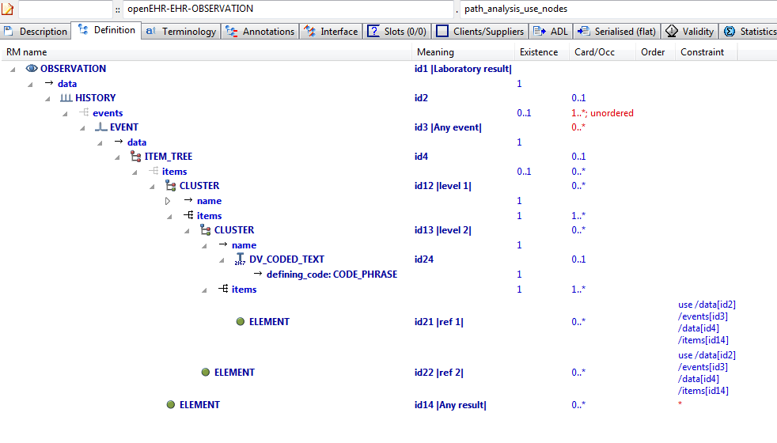

#### Path Analysis Use Nodes v1 AML Diagram

### Use Node Multiple v1 Example

This example, based on the openEHR Apgar archetype, shows the use of internal references (keyword 'use\_node') to re-use a subtree constraint structure repeatedly elsewhere in the archetype.

#### Use Node Multiple v1 ADL

OBSERVATION[id1] matches { -- Apgar score

data matches {

HISTORY[id3] matches {

events cardinality matches {1..\*; unordered} matches {

POINT\_EVENT[id4] occurrences matches {0..1} matches { -- 1 minute

offset matches {

DV\_DURATION[id46] matches {

value matches {PT1M}

}

}

data matches {

ITEM\_LIST[id2] matches {

items cardinality matches {1..6; ordered} matches {

ELEMENT[id10] occurrences matches {0..1} matches { -- Respiratory effort

value matches {

DV\_ORDINAL[id47] matches {

[value, symbol] matches {

[{0}, {[at11]}],

[{1}, {[at12]}],

[{2}, {[at13]}]

}

}

}

}

ELEMENT[id6] occurrences matches {0..1} matches { -- Heart Rate

value matches {

DV\_ORDINAL[id48] matches {

[value, symbol] matches {

[{0}, {[at7]}],

[{1}, {[at8]}],

[{2}, {[at9]}]

}

}

}

}

ELEMENT[id14] occurrences matches {0..1} matches { -- Muscle tone

value matches {

DV\_ORDINAL[id49] matches {

[value, symbol] matches {

[{0}, {[at15]}],

[{1}, {[at16]}],

[{2}, {[at17]}]

}

}

}

}

ELEMENT[id18] occurrences matches {0..1} matches { -- Reflex irritability

value matches {

DV\_ORDINAL[id50] matches {

[value, symbol] matches {

[{0}, {[at19]}],

[{1}, {[at20]}],

[{2}, {[at21]}]

}

}

}

}

ELEMENT[id22] occurrences matches {0..1} matches { -- Skin colour

value matches {

DV\_ORDINAL[id51] matches {

[value, symbol] matches {

[{0}, {[at23]}],

[{1}, {[at24]}],

[{2}, {[at25]}]

}

}

}

}

ELEMENT[id26] occurrences matches {0..1} matches { -- Total

value matches {

DV\_COUNT[id52] matches {

magnitude matches {|0..10|}

}

}

}

}

}

}

}

POINT\_EVENT[id27] occurrences matches {0..1} matches { -- 2 minute

offset matches {

DV\_DURATION[id53] matches {

value matches {PT2M}

}

}

data matches {

use\_node ITEM\_LIST[id41] /data[id3]/events[id4]/data[id2] -- /data[id3]/events[1 minute]/data[id2]

}

}

POINT\_EVENT[id28] occurrences matches {0..1} matches { -- 3 minute

offset matches {

DV\_DURATION[id54] matches {

value matches {PT3M}

}

}

data matches {

use\_node ITEM\_LIST[id42] /data[id3]/events[id4]/data[id2] -- /data[id3]/events[1 minute]/data[id2]

}

}

POINT\_EVENT[id29] occurrences matches {0..1} matches { -- 5 minute

offset matches {

DV\_DURATION[id55] matches {

value matches {PT5M}

}

}

data matches {

use\_node ITEM\_LIST[id43] /data[id3]/events[id4]/data[id2] -- /data[id3]/events[1 minute]/data[id2]

}

}

POINT\_EVENT[id32] occurrences matches {0..1} matches { -- 10 minute

offset matches {

DV\_DURATION[id56] matches {

value matches {PT10M}

}

}

data matches {

use\_node ITEM\_LIST[id44] /data[id3]/events[id4]/data[id2] -- /data[id3]/events[1 minute]/data[id2]

}

}

EVENT[id38] occurrences matches {0..\*} matches { -- Any event

data matches {

use\_node ITEM\_LIST[id45] /data[id3]/events[id4]/data[id2] -- /data[id3]/events[1 minute]/data[id2]

}

}

}

}

}

protocol matches {

ITEM\_LIST[id30] matches {

items matches {

ELEMENT[id31] occurrences matches {0..1} matches { -- Notes on measurement

value matches {

DV\_TEXT[id57]

}

}

}

}

}

}

#### Use Node Multiple v1 ADL Diagram

#### Use Node Multiple v1 AML Diagram

## Description Annotations Examples

### Annotations Rm Path v1 Example

Demonstrate annotations on pure Reference Model paths, i.e. paths that must be valid, but have not been archetyped. They are thus still valid for annotations.

#### Annotations Rm Path v1 ADL

COMPOSITION[id1] matches { -- Prescription

category matches {

DV\_CODED\_TEXT[id10] matches {

defining\_code matches {[at1]}

}

}

context matches {

EVENT\_CONTEXT[id11] matches {

other\_context matches {

ITEM\_TREE[id2] matches {

items matches {

CLUSTER[id3] occurrences matches {0..\*} matches { -- Qualification

items matches {

ELEMENT[id4] occurrences matches {0..1} matches { -- OrderID

value matches {

DV\_EHR\_URI[id12]

DV\_IDENTIFIER[id13]

}

}

ELEMENT[id5] occurrences matches {0..\*} matches { -- Endorsement

value matches {

DV\_TEXT[id14]

}

}

ELEMENT[id6] occurrences matches {0..\*} matches { -- AuthorisationID

value matches {

DV\_IDENTIFIER[id15]

}

}

ELEMENT[id7] occurrences matches {0..\*} matches { -- Comment

value matches {

DV\_TEXT[id16]

}

}

}

}

}

}

}

}

}

content cardinality matches {1..\*; unordered} matches {

allow\_archetype INSTRUCTION[id8] occurrences matches {1..\*} matches { -- Medication instruction

include

archetype\_id/value matches {/openEHR-EHR-INSTRUCTION\.medication\.v1/}

}

allow\_archetype ENTRY[id9] occurrences matches {0..\*} matches { -- Other data

include

archetype\_id/value matches {/.\*/}

}

}

}

#### Annotations Rm Path v1 ADL Diagram

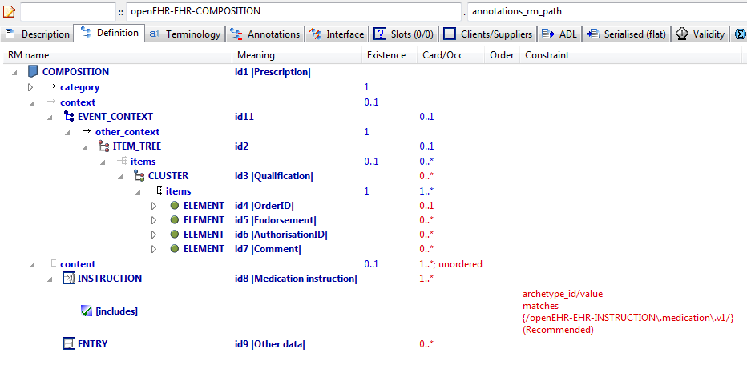

#### Annotations Rm Path v1 AML Diagram

NeuroMax:Users:patrick:git-opencimi:AML:adl-examples-for-aml:aml_diagrams:openEHR-EHR-COMPOSITION.annotations_rm_path.v1.pdf

### Annotations 1st Child v1 Example

To test use of annotations in a specialised archetype, on specialised paths.

#### Annotations 1st Child v1 ADL

EVALUATION[id1.1] matches { -- Exclusion statement - Adverse Reaction

/data[id2]/items matches {

ELEMENT[id0.7] occurrences matches {0..1} matches { -- No known adverse reaction to

value matches {

DV\_TEXT[id0.5]

}

}

ELEMENT[id0.8] occurrences matches {0..1} matches { -- No known allergic reaction to

value matches {

DV\_TEXT[id0.6]

}

}

ELEMENT[id0.9] occurrences matches {0..1} matches { -- No known hypersensitivity reaction to

value matches {

DV\_TEXT[id0.7] -- No known adverse reaction to

}

}

ELEMENT[id0.10] occurrences matches {0..1} matches { -- No known intolerance to

value matches {

DV\_TEXT[id0.8] -- No known allergic reaction to

}

}

}

}

#### Annotations 1st Child v1 ADL Diagram

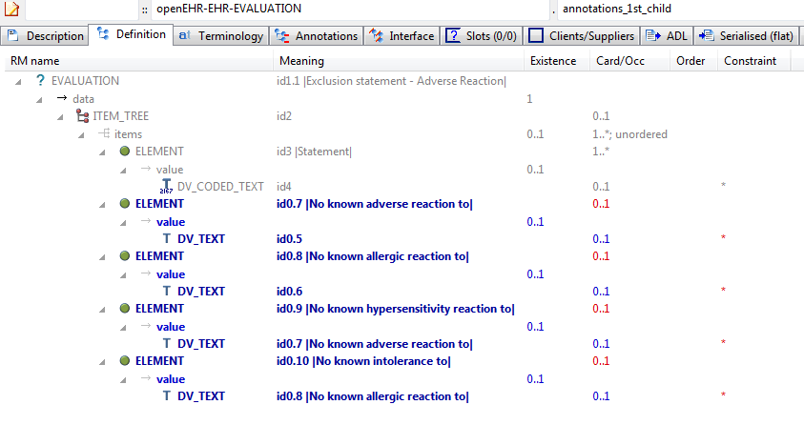

#### Annotations 1st Child v1 AML Diagram

NeuroMax:Users:patrick:git-opencimi:AML:adl-examples-for-aml:aml_diagrams:openEHR-EHR-EVALUATION.annotations_1st_child.v1.pdf

### Annotations Only Child v1 Example

To test use of specialisation that adds only annotations, i.e. no other changes.

#### Annotations Only Child v1 ADL

EVALUATION[id1.1] -- Annotations specialisation

#### Annotations Only Child v1 ADL Diagram

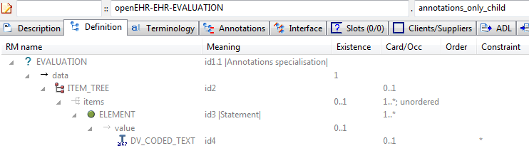

#### Annotations Only Child v1 AML Diagram

NeuroMax:Users:patrick:git-opencimi:AML:adl-examples-for-aml:aml_diagrams:openEHR-EHR-EVALUATION.annotations_only_child.v1.pdf

### Annotations Parent v1 Example

Archetype containing various kinds of annotation, including notes, requirements and UI processing hints.

#### Annotations Parent v1 ADL

EVALUATION[id1] matches { -- General statement of exclusions or states

data matches {

ITEM\_TREE[id2] matches {

items cardinality matches {1..\*; unordered} matches {

ELEMENT[id3] occurrences matches {1..\*} matches { -- Statement

value matches {

DV\_CODED\_TEXT[id4]

}

}

}

}

}

}

#### Annotations Parent v1 ADL Diagram

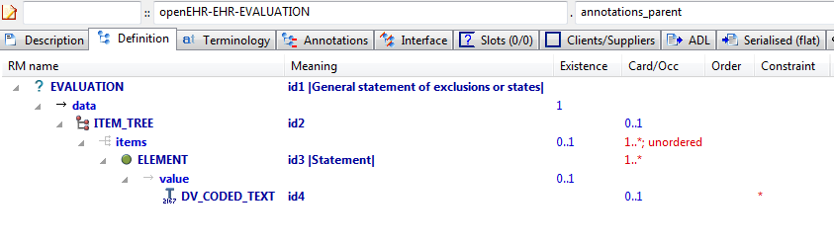

#### Annotations Parent v1 AML Diagram

NeuroMax:Users:patrick:git-opencimi:AML:adl-examples-for-aml:aml_diagrams:openEHR-EHR-EVALUATION.annotations_parent.v1.pdf

## Description Identification Examples

### Full Id 1 v1 Example

Test full namespaced and versioned archetype identifier.

#### Full Id 1 v1 ADL

OBSERVATION[id1] matches { -- top-level archetype

data

}

#### Full Id 1 v1 ADL Diagram

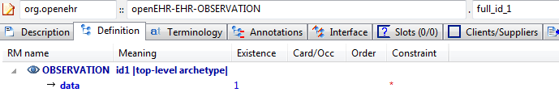

#### Full Id 1 v1 AML Diagram

### No Ns Inherit Ns v2 Example

Test full namespaced published versioned archetype identifier containing semver.org style 'rc' qualifier at end (release candidate).

#### No Ns Inherit Ns v2 ADL

OBSERVATION[id1.1] matches { -- specialised archetype

data matches {

HISTORY[id0.2]

}

}

#### No Ns Inherit Ns v2 ADL Diagram

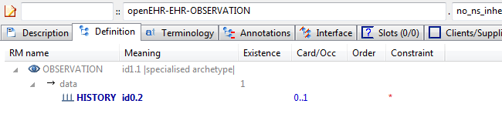

#### No Ns Inherit Ns v2 AML Diagram

NeuroMax:Users:patrick:git-opencimi:AML:adl-examples-for-aml:aml_diagrams:openEHR-EHR-OBSERVATION.no_ns_inherit_ns.v2.pdf

### Ns Inherit Ns v1 Example

Test full namespaced and versioned id that includes semver.org style 'alpha' qualifier at the end.

#### Ns Inherit Ns v1 ADL

OBSERVATION[id1.1] matches { -- specialised archetype

data matches {

HISTORY[id0.3]

}

}

#### Ns Inherit Ns v1 ADL Diagram

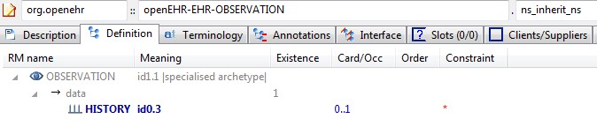

#### Ns Inherit Ns v1 AML Diagram

### Other Ns Inherit Ns v5 Example

Test specialisation of an archetype that has a namespaced and versioned identifier, by another archetype which has a different namespace.

#### Other Ns Inherit Ns v5 ADL

OBSERVATION[id1.1] matches { -- specialised archetype

data matches {

HISTORY[id0.4]

}

}

#### Other Ns Inherit Ns v5 ADL Diagram

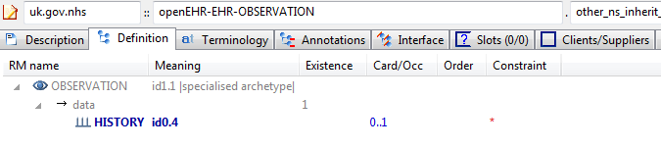

#### Other Ns Inherit Ns v5 AML Diagram

## Description Meta\_data Examples

### Child With Oid v1 Example

Example specialised archetype containing an ISO OID uid field.

#### Child With Oid v1 ADL

WHOLE[id1.1] matches { -- Child archetype with Oid

string\_attr1 matches {"test"}

}

#### Child With Oid v1 ADL Diagram

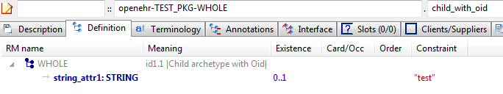

#### Child With Oid v1 AML Diagram

### Child With Uid v1 Example

Example specialised archetype containing a GUID uid field

#### Child With Uid v1 ADL

WHOLE[id1.1] matches { -- Child archetype with Uid

string\_attr1 matches {"test"}

}

#### Child With Uid v1 ADL Diagram

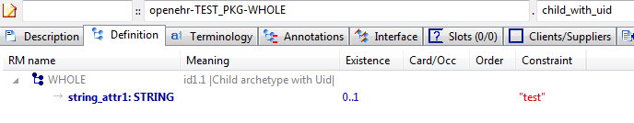

#### Child With Uid v1 AML Diagram

### Child With Uid And Other Metadata v1 Example

Example specialised archetype containing a uid and other meta-data that maps to AOM AUTHORED\_ARCHETYPE.other\_meta\_data. Values with same-named keys override those in the parent.

#### Child With Uid And Other Metadata v1 ADL

WHOLE[id1.1] -- Parent archetype with uid

#### Child With Uid And Other Metadata v1 ADL Diagram

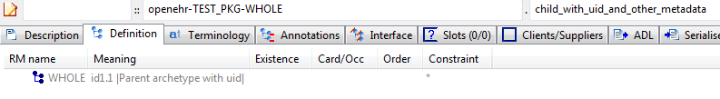

#### Child With Uid And Other Metadata v1 AML Diagram

### Full Meta Data v0.0.1 Example

This archetype demonstrates the use of governance meta-data.

#### Full Meta Data v0.0.1 ADL

WHOLE[id1] -- -

#### Full Meta Data v0.0.1 ADL Diagram

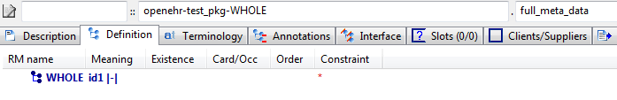

#### Full Meta Data v0.0.1 AML Diagram

### Parent With Oid v1 Example

Example top-level archetype containing an ISO OID uid field.

#### Parent With Oid v1 ADL

WHOLE[id1] -- Parent archetype with Oid

#### Parent With Oid v1 ADL Diagram

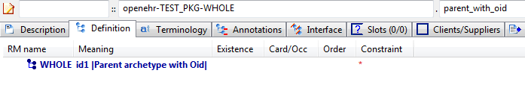

#### Parent With Oid v1 AML Diagram

### Parent With Uid v1 Example

Example top-level archetype containing a GUID uid field.

#### Parent With Uid v1 ADL

WHOLE[id1] -- Parent archetype with uid

#### Parent With Uid v1 ADL Diagram

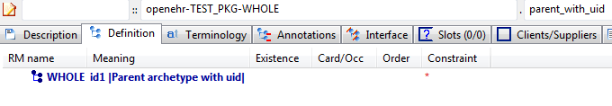

#### Parent With Uid v1 AML Diagram

### Parent With Uid And Other Metadata v1 Example

Example top-level archetype containing a uid and other meta-data that maps to AOM AUTHORED\_ARCHETYPE.other\_meta\_data

#### Parent With Uid And Other Metadata v1 ADL

WHOLE[id1] -- Parent archetype with uid

#### Parent With Uid And Other Metadata v1 ADL Diagram

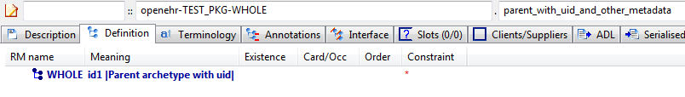

#### Parent With Uid And Other Metadata v1 AML Diagram

## Description Text Examples

### Quoted Strings v1 Example

This archetype should parse fine, and when saved and reparsed, no changes should occur in the strings of the at0001 term, i.e. the quoted slash and quoted double quote should remain as they are. However, both should display in the GUI without the backslash symbol

#### Quoted Strings v1 ADL

CLUSTER[id1] matches { -- unknown

items matches {

ELEMENT[id2] occurrences matches {0..1} matches { -- a\b

value matches {

DV\_CODED\_TEXT[id4] matches {

defining\_code matches {[ac1]} -- a\b

}

}

}

ELEMENT[id3] occurrences matches {0..1} matches { -- \a\

value matches {

DV\_TEXT[id5] matches {

value matches {"No quoting should happen here"}

}

}

}

}

}

#### Quoted Strings v1 ADL Diagram

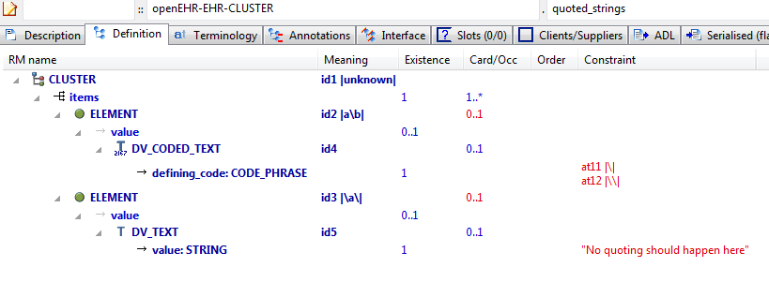

#### Quoted Strings v1 AML Diagram

NeuroMax:Users:patrick:git-opencimi:AML:adl-examples-for-aml:aml_diagrams:openEHR-EHR-CLUSTER.quoted_strings.v1.pdf

### Unicode Farsi v1 Example

Test unicode language archetype with Farsi translation

#### Unicode Farsi v1 ADL

EVALUATION[id1] matches { -- Risk of condition based on family history

data matches {

ITEM\_TREE[id2] matches {

items cardinality matches {1..\*; ordered} matches {

ELEMENT[id3] matches { -- Index condition

value matches {

DV\_TEXT[id131]

}

}

ELEMENT[id5] occurrences matches {0..1} matches { -- Assessed risk

value matches {

DV\_CODED\_TEXT[id132] matches {

defining\_code matches {[ac2]} -- Assessed risk

}

}

}

CLUSTER[id102] occurrences matches {0..1} matches { -- Affected relatives

items matches {

CLUSTER[id103] occurrences matches {0..\*} matches { -- Relative

name matches {

DV\_CODED\_TEXT[id133] matches {

defining\_code matches {[ac1]} -- Relationship

}

}

items matches {

ELEMENT[id104] occurrences matches {0..1} matches { -- Name

value matches {

DV\_TEXT[id134]

}

}

ELEMENT[id105] occurrences matches {0..1} matches { -- Age at onset

value matches {

DV\_QUANTITY[id135] matches {

property matches {[at127]}

[units, magnitude] matches {

[{"yr"}, {|0.0..200.0|}],

[{"mth"}, {|0.0..36.0|}],

[{"wk"}, {|0.0..52.0|}],

[{"day"}, {|0.0..56.0|}]

}

}

}

}

ELEMENT[id128] occurrences matches {0..1} matches { -- Date of onset

value matches {

DV\_DATE[id136] matches {

value matches {yyyy-??-??}

}

}

}

ELEMENT[id106] occurrences matches {0..1} matches { -- Age at death

value matches {

DV\_QUANTITY[id137] matches {

property matches {[at128]}

units matches {"yr"}

magnitude matches {|0.0..200.0|}

}

}

}

ELEMENT[id107] occurrences matches {0..1} matches { -- Date of death

value matches {

DV\_DATE[id138] matches {

value matches {yyyy-??-??}

}

}

}

ELEMENT[id108] occurrences matches {0..1} matches { -- Index condition was cause of death

value matches {

DV\_BOOLEAN[id139] matches {

value matches {True, False}

}

}

}

ELEMENT[id109] occurrences matches {0..1} matches { -- Severity

value matches {

DV\_ORDINAL[id140] matches {

[value, symbol] matches {

[{1}, {[at110]}],

[{4}, {[at111]}],

[{7}, {[at112]}]

}

}

}

}

ELEMENT[id129] occurrences matches {0..1} matches { -- More specific condition

value matches {

DV\_TEXT[id141]

}

}

ELEMENT[id113] occurrences matches {0..1} matches { -- Clinical description

value matches {

DV\_TEXT[id142]

}

}

ELEMENT[id114] occurrences matches {0..1} matches { -- Genetic relative

value matches {

DV\_BOOLEAN[id143] matches {

value matches {True, False}

}

}

}

}

}

}

}

CLUSTER[id115] occurrences matches {0..\*} matches { -- Affected ratio

items cardinality matches {1..4; ordered} matches {

ELEMENT[id116] occurrences matches {0..1} matches { -- Degree

value matches {

DV\_CODED\_TEXT[id144] matches {

defining\_code matches {[ac3]} -- Degree

}

}

}

ELEMENT[id123] occurrences matches {0..1} matches { -- Gender

value matches {

DV\_CODED\_TEXT[id145] matches {

defining\_code matches {[ac4]} -- Gender

}

}

}

ELEMENT[id127] occurrences matches {0..1} matches { -- Number unaffected

value matches {

DV\_COUNT[id146] matches {

magnitude matches {|0..100|}

}

}

}

ELEMENT[id130] matches { -- Number affected

value matches {

DV\_COUNT[id147] matches {

magnitude matches {|0..100|}

}

}

}

}

}

}

}

}

protocol matches {

ITEM\_LIST[id11] matches {

items matches {

ELEMENT[id12] occurrences matches {0..1} matches { -- Risk calculation

value matches {

DV\_TEXT[id148]

}

}

}

}

}

}

#### Unicode Farsi v1 ADL Diagram

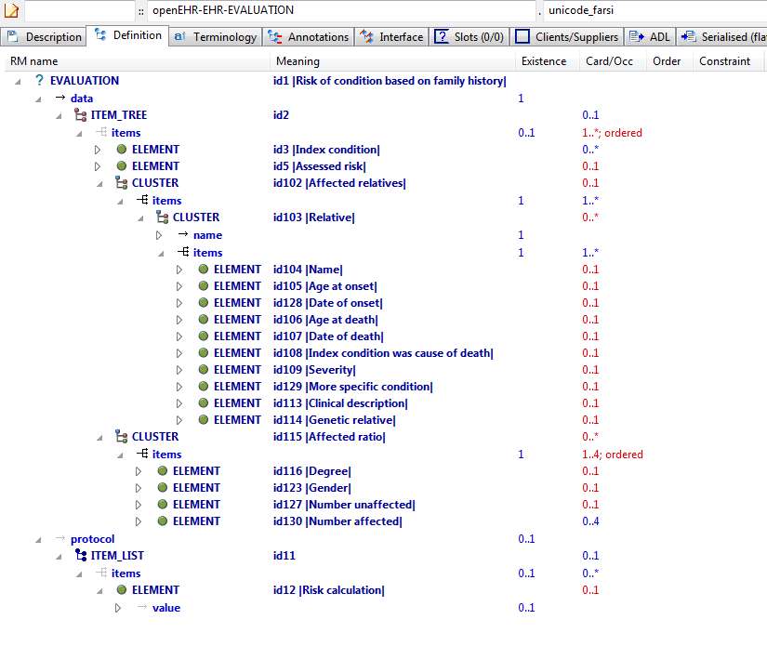

#### Unicode Farsi v1 AML Diagram

### Max Description v1 Example

a quoi ça sert

#### Max Description v1 ADL

OBSERVATION[id1] matches { -- most minimal

data

}

#### Max Description v1 ADL Diagram

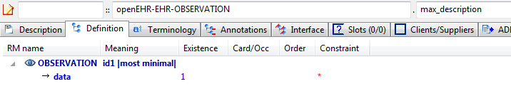

#### Max Description v1 AML Diagram

NeuroMax:Users:patrick:git-opencimi:AML:adl-examples-for-aml:aml_diagrams:openEHR-EHR-OBSERVATION.max_description.v1.pdf

### Three Languages v1 Example

a quoi ça sert

#### Three Languages v1 ADL

OBSERVATION[id1] matches { -- most minimal

data

}

#### Three Languages v1 ADL Diagram

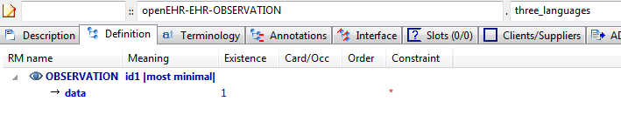

#### Three Languages v1 AML Diagram

NeuroMax:Users:patrick:git-opencimi:AML:adl-examples-for-aml:aml_diagrams:openEHR-EHR-OBSERVATION.three_languages.v1.pdf

### Long Lines v1 Example

what this is for

#### Long Lines v1 ADL

ENTRY[id1] matches { -- most minimal sdfasdjb adsnfsadf s dns cshdisdh;sidoew dfhswdisdh sd swdf

element\_attr

}

#### Long Lines v1 ADL Diagram

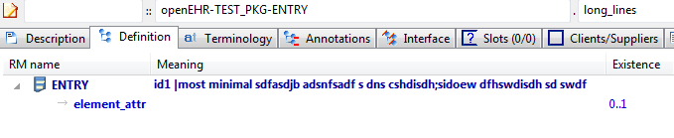

#### Long Lines v1 AML Diagram

## Flattening Examples

### Lab Test Panel - Lipid Studies v1 Example

Test flattening of overlays of new elements onto cloned structures. This archetype overlays one changed element on a repeated cloning of a structure with 4 elements. The flattened result will show all clones of those structures, with each being made up of the unchanged (inherited) elements, and the overridden elements defined in this archetype.

#### Lab Test Panel - Lipid Studies v1 ADL

CLUSTER[id1.1] matches { -- Lipid studies panel

/items matches {

CLUSTER[id3.1] matches { -- LDL Cholesterol Result

items matches {

ELEMENT[id2.1] matches { -- LDL Cholesterol

value matches {

DV\_QUANTITY[id0.1] matches {

property matches {[at0.1]}

magnitude matches {|>=0.0|}

units matches {"mmol/l"}

}

}

}

}

}

CLUSTER[id3.2] matches { -- HDL Cholesterol Result

items matches {

ELEMENT[id2.2] matches { -- HDL Cholesterol

value matches {

DV\_QUANTITY[id0.2] matches {

property matches {[at0.1]}

magnitude matches {|>=0.0|}

units matches {"mmol/l"}

}

}

}

}

}

CLUSTER[id3.3] matches { -- Ratio Result

items matches {

ELEMENT[id2.3] matches { -- Ratio

value matches {

DV\_QUANTITY[id0.3] matches {

property matches {[at0.1]}

magnitude matches {|>=0.0|}

units matches {"mmol/l"}

}

}

}

}

}

CLUSTER[id3.4] matches { -- Triglyceride Result

items matches {

ELEMENT[id2.4] matches { -- Triglyceride

value matches {

DV\_QUANTITY[id0.4] matches {

property matches {[at0.1]}

magnitude matches {|>=0.0|}

units matches {"mosmol/l"}

}

}

}

}

}

CLUSTER[id3.5] matches { -- Total Result

items matches {

ELEMENT[id2.5] matches { -- Total cholesterol

value matches {

DV\_QUANTITY[id0.5] matches {

property matches {[at0.1]}

magnitude matches {|>=0.0|}

units matches {"mosmol/l"}

}

}

}

}

}

CLUSTER[id3.6] -- ! - Laboratory Result

}

}

#### Lab Test Panel - Lipid Studies v1 ADL Diagram

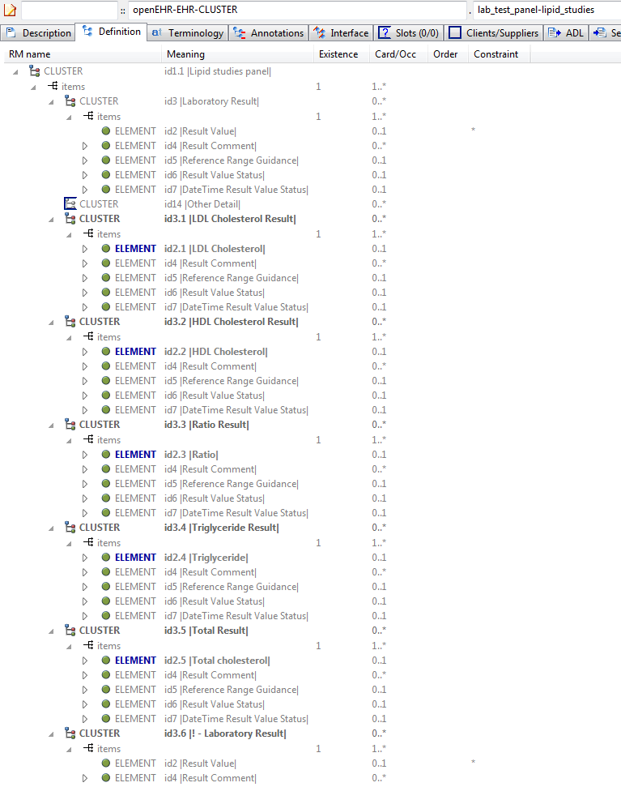

#### Lab Test Panel - Lipid Studies v1 AML Diagram

### Lab Test Panel v1 Example

Parent for flattening tests on lab-style archetypes

#### Lab Test Panel v1 ADL

CLUSTER[id1] matches { -- Laboratory test panel

items matches {

CLUSTER[id3] matches { -- Laboratory Result

items matches {

ELEMENT[id2] occurrences matches {0..1} -- Result Value

ELEMENT[id4] matches { -- Result Comment

value matches {

DV\_TEXT[id15]

}

}

ELEMENT[id5] occurrences matches {0..1} matches { -- Reference Range Guidance

value matches {

DV\_TEXT[id16]

}

}

ELEMENT[id6] occurrences matches {0..1} matches { -- Result Value Status

value matches {

DV\_CODED\_TEXT[id17] matches {

defining\_code matches {[ac1]} -- Result Value Status (synthesised)

}

}

}

ELEMENT[id7] occurrences matches {0..1} matches { -- DateTime Result Value Status

value matches {

DV\_DATE\_TIME[id18]

}

}

}

}

allow\_archetype CLUSTER[id14] matches { -- Other Detail

include

archetype\_id/value matches {/.\*/}

}

}

}

#### Lab Test Panel v1 ADL Diagram

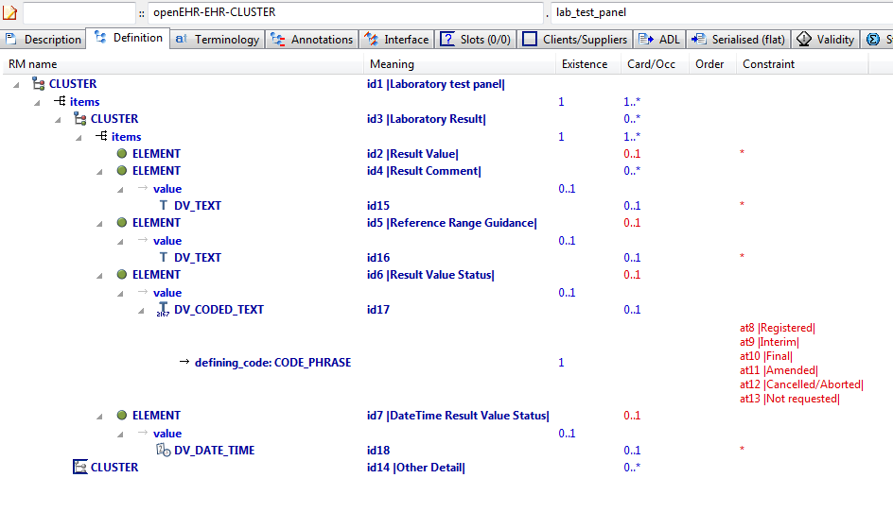

#### Lab Test Panel v1 AML Diagram

### Request - Pathology Test v1 Example

Test flattening when child archetype contains a differential path that contains an overridden id code midway through (id122.1).

#### Request - Pathology Test v1 ADL

INSTRUCTION[id1.1] matches { -- PathologyTest Request

/activities[id2]/description[id10]/items[id122.1]/name matches {

DV\_TEXT[id0.146]

}

/activities[id2]/description[id10]/items[id136.1]/name matches {

DV\_TEXT[id0.147]

}

}

#### Request - Pathology Test v1 ADL Diagram

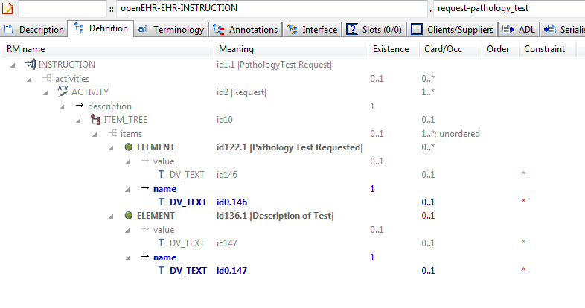

#### Request - Pathology Test v1 AML Diagram

NeuroMax:Users:patrick:git-opencimi:AML:adl-examples-for-aml:aml_diagrams:openEHR-EHR-INSTRUCTION.request-pathology_test.v1.pdf

### Request v1 Example

Parent archetype for archetypes testing flattening when child archetype contains a differential path with an overridden id code.

#### Request v1 ADL

INSTRUCTION[id1] matches { -- Healthcare service request

activities matches {

ACTIVITY[id2] occurrences matches {1..\*} matches { -- Request

description matches {

ITEM\_TREE[id10] matches {

items cardinality matches {1..\*; unordered} matches {

ELEMENT[id122] matches { -- Service requested

value matches {

DV\_TEXT[id146]

}

}

ELEMENT[id136] occurrences matches {0..1} matches { -- Description of service

value matches {

DV\_TEXT[id147]

}

}

}

}

}

}

}

}

#### Request v1 ADL Diagram

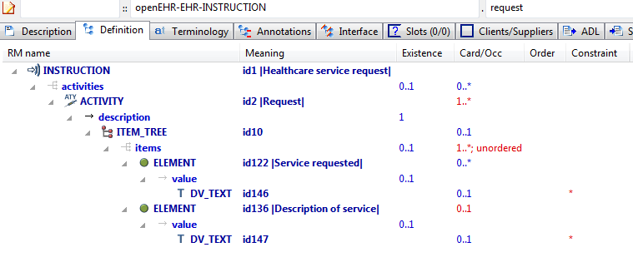

#### Request v1 AML Diagram

NeuroMax:Users:patrick:git-opencimi:AML:adl-examples-for-aml:aml_diagrams:openEHR-EHR-INSTRUCTION.request.v1.pdf

### Flat Test Parent 1 - Add Node Use Node v1 Example

Test flattening of differential path containing terminal attribute not in parent ('state'); test internal references to path in flat parent and path in current archetype.

#### Flat Test Parent 1 - Add Node Use Node v1 ADL

OBSERVATION[id1.1] matches { -- Blood Glucose Test Result

/data[id2]/events[id3]/state matches {

ITEM\_TREE[id0.8] matches {

items matches {

ELEMENT[id0.9] occurrences matches {0..1} matches { -- Fasting state

value matches {

DV\_BOOLEAN[id0.17] matches {

value matches {True}

}

}

}

}

}

}

/data[id2]/events matches {

POINT\_EVENT[id0.2] occurrences matches {0..1} matches { -- Baseline Measurement

offset matches {

DV\_DURATION[id0.21] matches {

value matches {PT0S}

}

}

data matches {

use\_node ITEM\_TREE[id0.22] /data[id2]/events[id3]/data[id4] -- /data[id2]/events[id3]/data[id4]

}

state matches {

use\_node ITEM\_TREE[id0.23] /data[id2]/events[id3]/state[id0.8] -- /data[id2]/events[id3]/state[id0.8]

}

}

}

}

#### Flat Test Parent 1 - Add Node Use Node v1 ADL Diagram

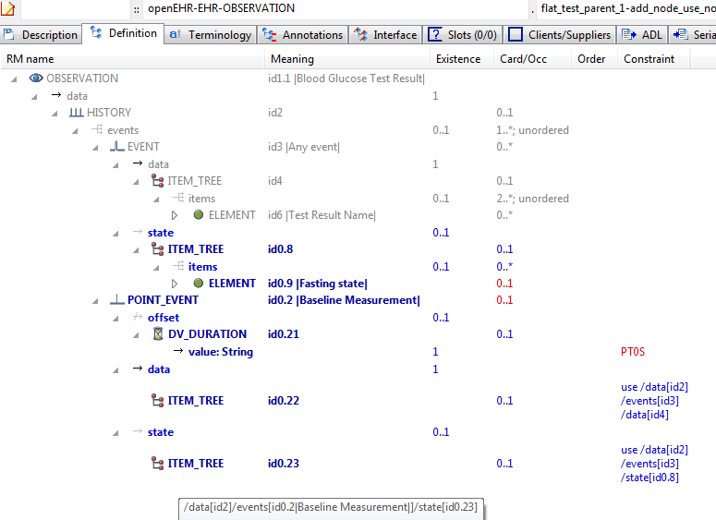

#### Flat Test Parent 1 - Add Node Use Node v1 AML Diagram

### Flat Test Parent 1 v1 Example

Parent of archetypes for flattening tests

#### Flat Test Parent 1 v1 ADL

OBSERVATION[id1] matches { -- Pathology Test Result

data matches {

HISTORY[id2] matches {

events cardinality matches {1..\*; unordered} matches {

EVENT[id3] matches { -- Any event

data matches {

ITEM\_TREE[id4] matches {

items cardinality matches {2..\*; unordered} matches {

ELEMENT[id6] matches { -- Test Result Name

value matches {

DV\_TEXT[id112]

}

}

}

}

}

}

}

}

}

}

#### Flat Test Parent 1 v1 ADL Diagram

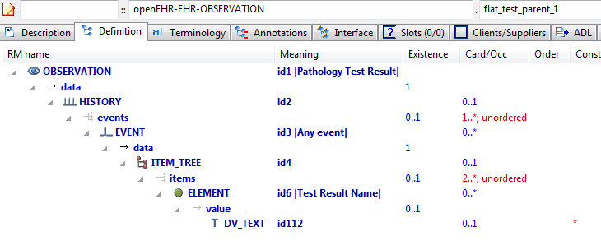

#### Flat Test Parent 1 v1 AML Diagram

NeuroMax:Users:patrick:git-opencimi:AML:adl-examples-for-aml:aml_diagrams:openEHR-EHR-OBSERVATION.flat_test_parent_1.v1.pdf

### Flattening Parent 1 v1 Example

Overwrite parent 'matches-any' node (id13) with 2 child nodes.

#### Flattening Parent 1 v1 ADL

OBSERVATION[id1] matches { -- Substance Use

data matches {

HISTORY[id2] matches {

events cardinality matches {1..\*; unordered} matches {

EVENT[id3] occurrences matches {0..1} matches { -- Any event

data matches {

ITEM\_TREE[id4] matches {

items matches {

ELEMENT[id5] occurrences matches {0..1} matches { -- Substance

value matches {

DV\_TEXT[id20]

}

}

CLUSTER[id11] occurrences matches {0..1} matches { -- Consumption details

items matches {

ELEMENT[id12] occurrences matches {0..1} matches { -- Form

value matches {

DV\_TEXT[id21]

}

}

ELEMENT[id19] occurrences matches {0..1} matches { -- Method of use

value matches {

DV\_TEXT[id22]

}

}

ELEMENT[id6] occurrences matches {0..1} matches { -- Frequency

value matches {

DV\_CODED\_TEXT[id23] matches {

defining\_code matches {[ac1]} -- Frequency

}

}

}

ELEMENT[id13] occurrences matches {0..\*} -- Amount

}

}

ELEMENT[id14] occurrences matches {0..1} matches { -- Triggers

value matches {

DV\_TEXT[id24]

}

}

allow\_archetype CLUSTER[id15] occurrences matches {0..\*} matches { -- Readiness for change

include

archetype\_id/value matches {/openEHR-EHR-CLUSTER\.change\.v1/}

}

ELEMENT[id17] occurrences matches {0..1} matches { -- Evidence of dependence

value matches {

DV\_TEXT[id25]

}

}

}

}

}

}

}

}

}

}

#### Flattening Parent 1 v1 ADL Diagram

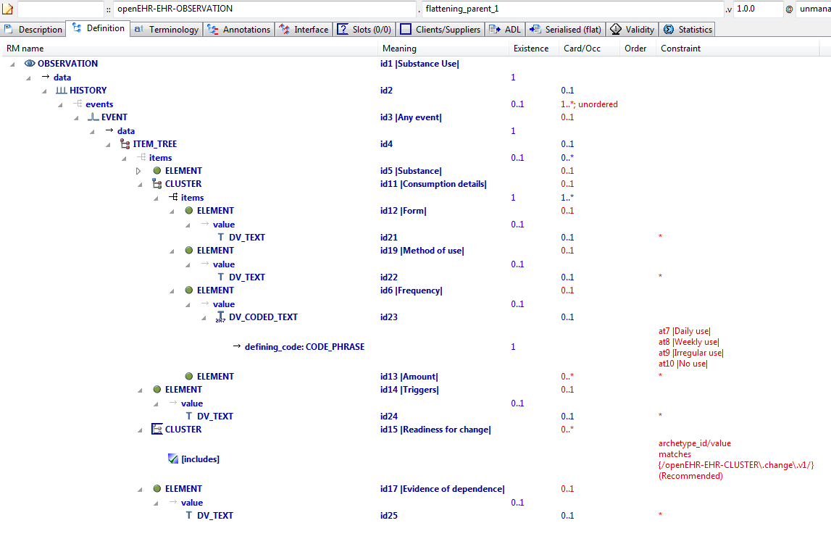

#### Flattening Parent 1 v1 AML Diagram

### Override To Multiple v1 Example

Parent of flattening example archetypes.

#### Override To Multiple v1 ADL

OBSERVATION[id1.1] matches { -- Tobacco Use

/data[id2]/events[id3]/data[id4]/items[id5]/value matches {

DV\_CODED\_TEXT[id20.1] matches {

defining\_code matches {[at0.2]}

}

}

/data[id2]/events[id3]/data[id4]/items[id11]/items[id12]/value matches {

DV\_CODED\_TEXT[id21.1] matches {

defining\_code matches {[ac0.1]} -- (added by post-parse processor)

}

}

/data[id2]/events[id3]/data[id4]/items[id11]/items matches {

ELEMENT[id13.1] matches { -- Number smoked

value matches {

DV\_QUANTITY[id0.5] matches {

property matches {[at0.7]}

units matches {"/h", "/d", "/wk"}

}

}

}

ELEMENT[id13.2] matches { -- Grams of tobacco

value matches {

DV\_QUANTITY[id0.6] matches {

property matches {[at0.8]}

units matches {"gm/d", "gm/wk"}

}

}

}

}

}

#### Override To Multiple v1 ADL Diagram

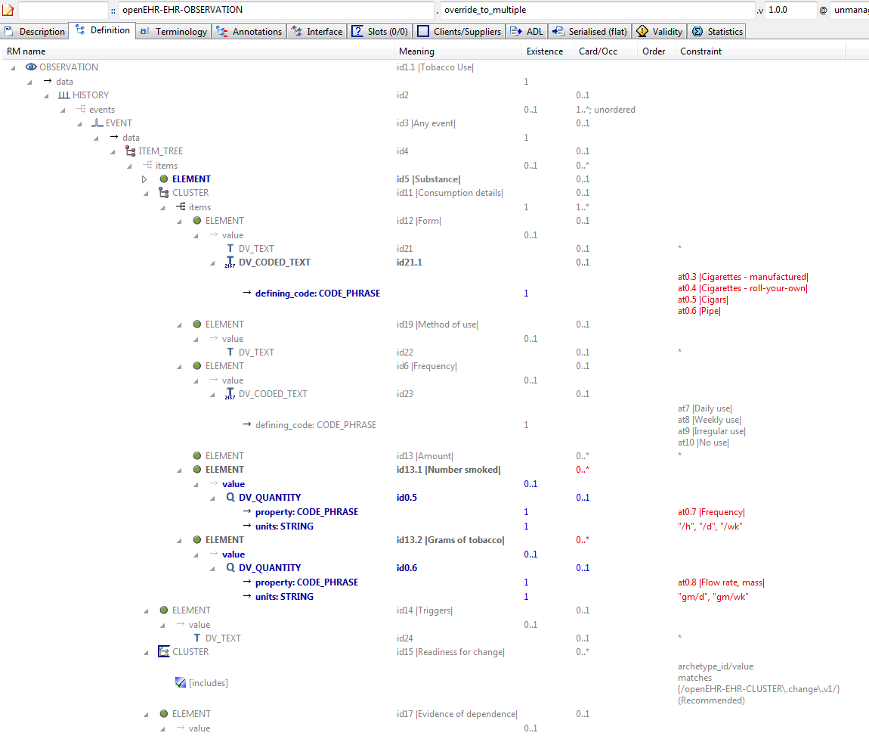

#### Override To Multiple v1 AML Diagram

## Reference\_model Enumeration\_types Examples

### Enum Type 1 v1 Example

Illustrate enumerated type constraints. In this archetype, the DV\_PROPORTION.type field has integer values that are actually the values of a declared enumeration type PROPORTION\_KIND based on the Integer primitive type.

#### Enum Type 1 v1 ADL

OBSERVATION[id1] matches { -- Enumeration test

data matches {

HISTORY[id2] matches {

events cardinality matches {1..\*; unordered} matches {

POINT\_EVENT[id3] occurrences matches {0..1} matches { -- Any event

data matches {

ITEM\_TREE[id4] matches {

items cardinality matches {1..\*; unordered} matches {

ELEMENT[id5] occurrences matches {0..1} matches { -- test enum 1

value matches {

DV\_PROPORTION[id6] matches {

numerator matches {|0.0..1.0|; 0.0}

is\_integral matches {False}

type matches {1}

}

}

}

ELEMENT[id7] occurrences matches {0..1} matches { -- test enum 2

value matches {

DV\_PROPORTION[id8] matches {

numerator matches {|0.0..1.0|; 0.0}

is\_integral matches {False}

type matches {2, 3}

}

}

}

}

}

}

}

}

}

}

}

#### Enum Type 1 v1 ADL Diagram

#### Enum Type 1 v1 AML Diagram

## Reference\_model Generic\_types Examples

### Generic Parameters v1 Example

Illustrate constraining of fields whose types in the RM are a generic type parameter, i.e. typically 'T', 'U' etc. In this example, the upper and lower fields are of type 'T' in the RM definition of DV\_INTERVAL.

#### Generic Parameters v1 ADL

CLUSTER[id1] matches { -- Specimen

items matches {

ELEMENT[id2] occurrences matches {0..1} matches { -- Datetime range

value matches {

DV\_INTERVAL<DV\_DATE\_TIME>[id3] matches {

upper matches {

DV\_DATE\_TIME[id4]

}

lower matches {

DV\_DATE\_TIME[id5]

}

}

}

}

}

}

#### Generic Parameters v1 ADL Diagram

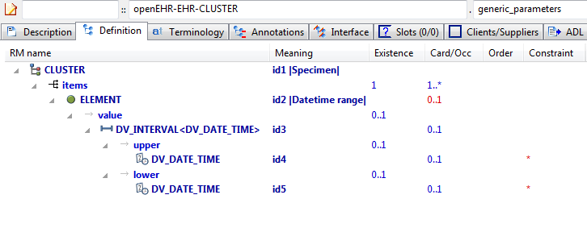

#### Generic Parameters v1 AML Diagram

### Rm Conforming Rm Subtype v1 Example

Test for conformance of RM subtype (here: POINT\_EVENT) to statically declared RM type (EVENT). This archetype should pass validation.

#### Rm Conforming Rm Subtype v1 ADL

OBSERVATION[id1] matches { -- An Observation

data matches {

HISTORY[id5] matches {

events cardinality matches {1..\*; unordered} matches {

POINT\_EVENT[id2] occurrences matches {0..1} matches { -- A Point\_event

offset matches {

DV\_DURATION[id6] matches {

value matches {PT1M}

}

}

data matches {

ITEM\_LIST[id7] matches {

items cardinality matches {1..6; ordered} matches {

ELEMENT[id3] occurrences matches {0..1} -- Element #1

ELEMENT[id4] occurrences matches {0..1} -- Element #2

}

}

}

}

}

}

}

}

#### Rm Conforming Rm Subtype v1 ADL Diagram

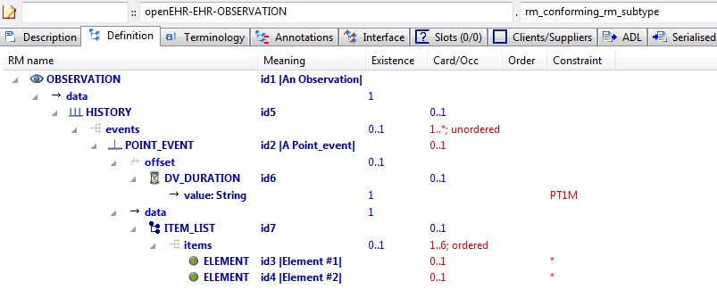

#### Rm Conforming Rm Subtype v1 AML Diagram

NeuroMax:Users:patrick:git-opencimi:AML:adl-examples-for-aml:aml_diagrams:openEHR-EHR-OBSERVATION.rm_conforming_rm_subtype.v1.pdf

### Rm Correct Non Generic v1 Example

Example containing properly constraints conforming to the RM, with no RM type overrides or generic type markers, even though one type (HISTORY) is declared generic in the RM.

#### Rm Correct Non Generic v1 ADL

OBSERVATION[id1] matches { -- an Observation

data matches {

HISTORY[id4] matches {

events cardinality matches {1..\*; unordered} matches {

EVENT[id3] occurrences matches {0..\*} matches { -- some Event

data matches {

ITEM\_LIST[id5]

}

}

}

}

}

}

#### Rm Correct Non Generic v1 ADL Diagram

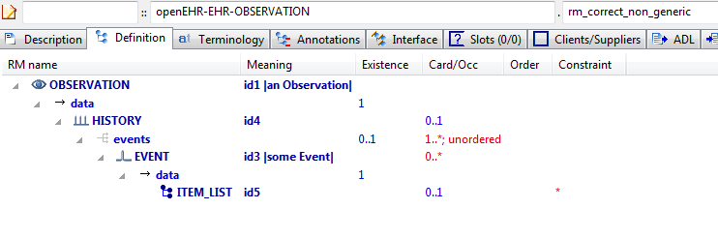

#### Rm Correct Non Generic v1 AML Diagram

NeuroMax:Users:patrick:git-opencimi:AML:adl-examples-for-aml:aml_diagrams:openEHR-EHR-OBSERVATION.rm_correct_non_generic.v1.pdf

## Specialisation Examples

### Code List Constrained v1 Example

Example of narrowing constraint of code list inherited from parent.

#### Code List Constrained v1 ADL

EVALUATION[id1.1] matches { -- Adverse reaction exclusions

/data[id2]/items[id3]/value/defining\_code matches {[ac1.1]}

}

#### Code List Constrained v1 ADL Diagram

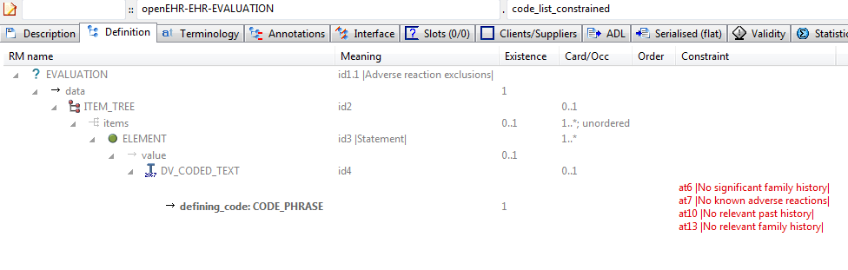

#### Code List Constrained v1 AML Diagram

NeuroMax:Users:patrick:git-opencimi:AML:adl-examples-for-aml:aml_diagrams:openEHR-EHR-EVALUATION.code_list_constrained.v1.pdf

### Code List Parent v1 Example

Archetype containing a C\_TERMINOLOGY\_CODE list which can be further constrained in child archetypes.

#### Code List Parent v1 ADL

EVALUATION[id1] matches { -- General statement of exclusions or states

data matches {

ITEM\_TREE[id2] matches {

items cardinality matches {1..\*; unordered} matches {

ELEMENT[id3] occurrences matches {1..\*} matches { -- Statement

value matches {

DV\_CODED\_TEXT[id4] matches {

defining\_code matches {[ac1]} -- Statement

}

}

}

}

}

}

}

#### Code List Parent v1 ADL Diagram

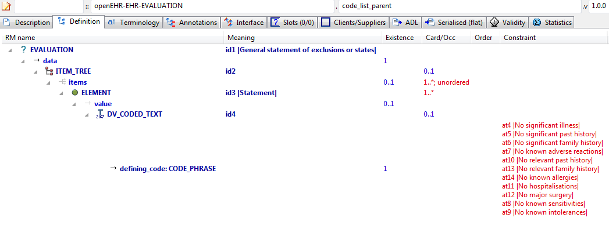

#### Code List Parent v1 AML Diagram

NeuroMax:Users:patrick:git-opencimi:AML:adl-examples-for-aml:aml_diagrams:openEHR-EHR-EVALUATION.code_list_parent.v1.pdf

### Body Temp Narrow Dv Quantity v1 Example

Specialised archetype illustrating constraint narrowing of a DV\_QUANTITY. In this example, the two logical possibilities from the parent, i.e. deg F and deg C are reduced to just the deg C constraint.

#### Body Temp Narrow Dv Quantity v1 ADL

OBSERVATION[id1.1] matches { -- Body temperature new GP

/data[id3]/events[id4]/data[id2]/items[id5]/value matches {

DV\_QUANTITY[id61] matches {

property matches {[at57]}

[units, precision] matches {

[{"°C"}, {1}]

}

}

}

}

#### Body Temp Narrow Dv Quantity v1 ADL Diagram

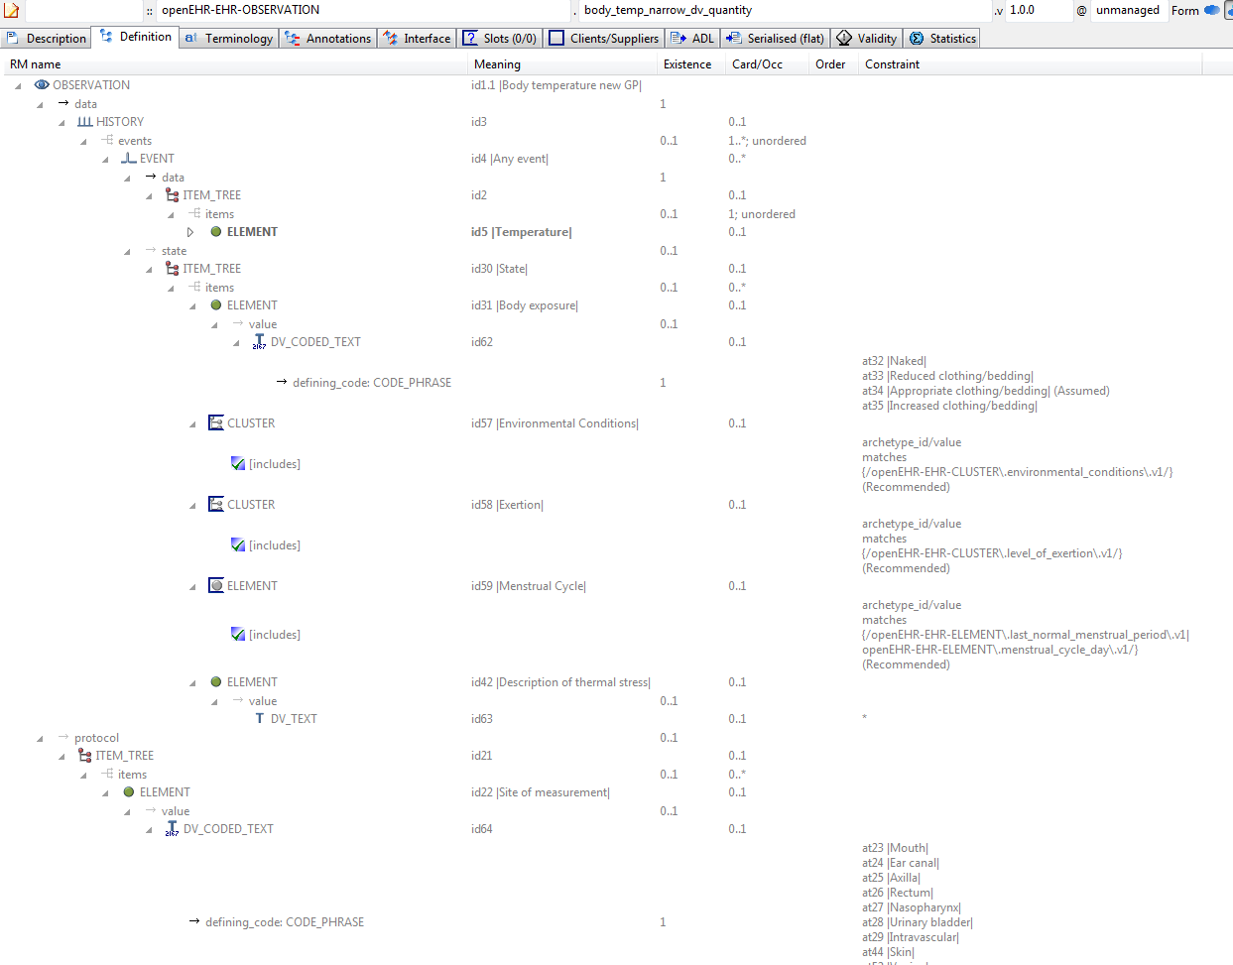

#### Body Temp Narrow Dv Quantity v1 AML Diagram

### Body Temp Redefine Exist Occ Example

Specialised archetype showing the use of constraints for existence and occurrences matches {0}. These are used to remove attributes and objects respectively.

#### Body Temp Redefine Exist Occ ADL

OBSERVATION[id1.1] matches { -- Body temperature new GP

/data[id3]/events[id4]/state existence matches {0}

/protocol[id21]/items matches {

allow\_archetype CLUSTER[id60] occurrences matches {0}

}

}

#### Body Temp Redefine Exist Occ ADL Diagram

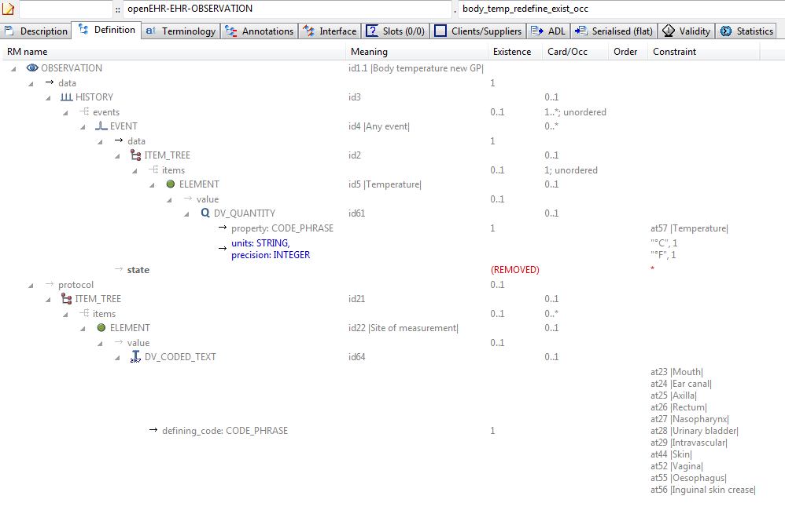

#### Body Temp Redefine Exist Occ AML Diagram

### Body Temp Test v1 Example

A parent archetype for testing various child refinements, including occurrences matches {0}.

#### Body Temp Test v1 ADL

OBSERVATION[id1] matches { -- Body temperature

data matches {

HISTORY[id3] matches {

events cardinality matches {1..\*; unordered} matches {

EVENT[id4] occurrences matches {0..\*} matches { -- Any event

data matches {

ITEM\_TREE[id2] matches {

items cardinality matches {1; unordered} matches {

ELEMENT[id5] matches { -- Temperature

value matches {

DV\_QUANTITY[id61] matches {

property matches {[at57]}

[units, precision] matches {

[{"°C"}, {1}],

[{"°F"}, {1}]

}

}

}

}

}

}

}

state matches {

ITEM\_TREE[id30] matches { -- State

items matches {

ELEMENT[id31] occurrences matches {0..1} matches { -- Body exposure

value matches {

DV\_CODED\_TEXT[id62] matches {

defining\_code matches {[ac1; at34]} -- Body exposure

}

}

}

allow\_archetype CLUSTER[id57] occurrences matches {0..1} matches { -- Environmental Conditions

include

archetype\_id/value matches {/openEHR-EHR-CLUSTER\.environmental\_conditions\.v1/}

}

allow\_archetype CLUSTER[id58] occurrences matches {0..1} matches { -- Exertion

include

archetype\_id/value matches {/openEHR-EHR-CLUSTER\.level\_of\_exertion\.v1/}

}

allow\_archetype ELEMENT[id59] occurrences matches {0..1} matches { -- Menstrual Cycle

include

archetype\_id/value matches {/openEHR-EHR-ELEMENT\.last\_normal\_menstrual\_period\.v1|openEHR-EHR-ELEMENT\.menstrual\_cycle\_day\.v1/}

}

ELEMENT[id42] occurrences matches {0..1} matches { -- Description of thermal stress

value matches {

DV\_TEXT[id63]

}

}

}

}

}

}

}

}

}

protocol matches {

ITEM\_TREE[id21] matches {

items matches {

ELEMENT[id22] occurrences matches {0..1} matches { -- Site of measurement

value matches {

DV\_CODED\_TEXT[id64] matches {

defining\_code matches {[ac2]} -- Site of measurement

}

}

}

allow\_archetype CLUSTER[id60] occurrences matches {0..1} matches { -- Device

include

archetype\_id/value matches {/openEHR-EHR-CLUSTER\.device\.v1/}

}

}

}

}

}

#### Body Temp Test v1 ADL Diagram

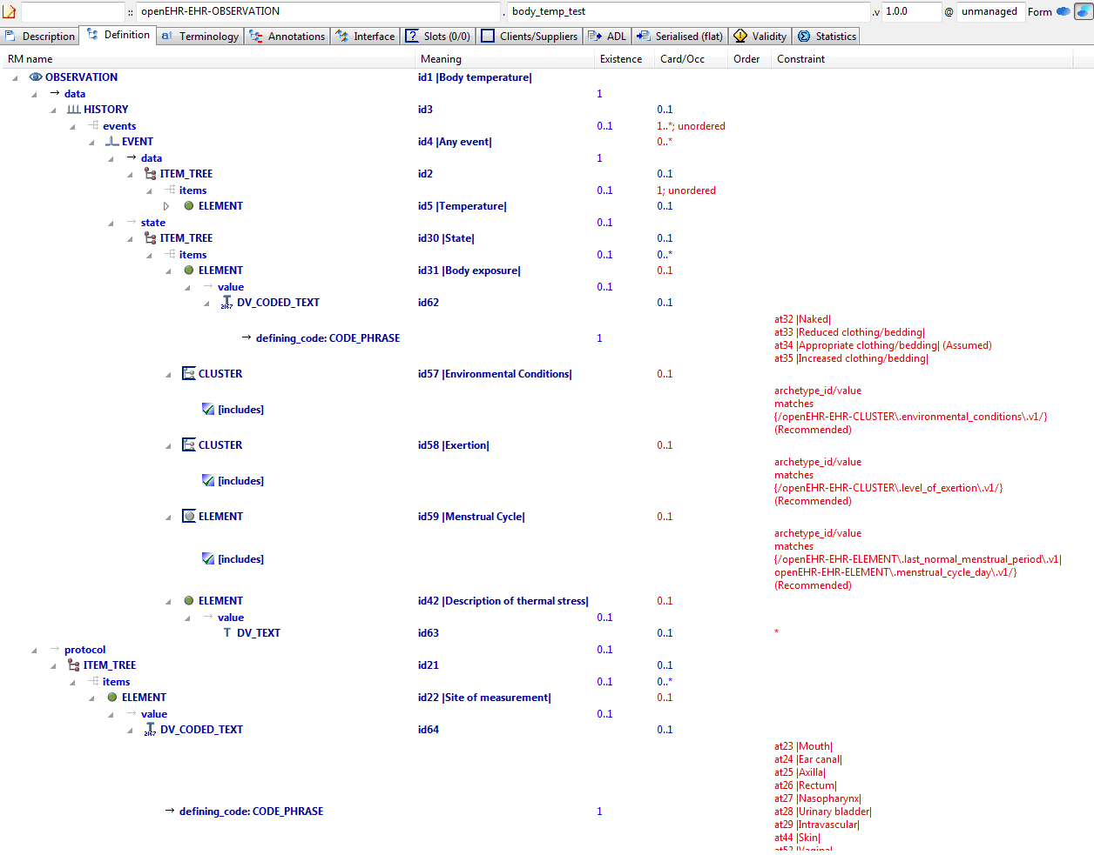

#### Body Temp Test v1 AML Diagram

### Ordering Added Nodes v1 Example

Example specialised archetype containing additional nodes and ordering markers within a container attribute defined in the parent. The parent container already includes member ELEMENTs, so the 'after' and 'before' markers in this descendant are used to obtain the intended overall order in the flattened result.

#### Ordering Added Nodes v1 ADL

OBSERVATION[id1.1] matches { -- specialisation containing ordered extension nodes

/data/events[id3]/data/items matches {

after [id5]

ELEMENT[id0.1] matches { -- Text field 2

value matches {

DV\_TEXT[id0.3] -- Text field 3

}

}

ELEMENT[id0.2] matches { -- Quantity 2

value matches {

DV\_QUANTITY[id0.4]

}

}

before [id8]

ELEMENT[id0.3] matches { -- Text field 3

value matches {

DV\_TEXT[id0.5]

}

}

}

}

#### Ordering Added Nodes v1 ADL Diagram

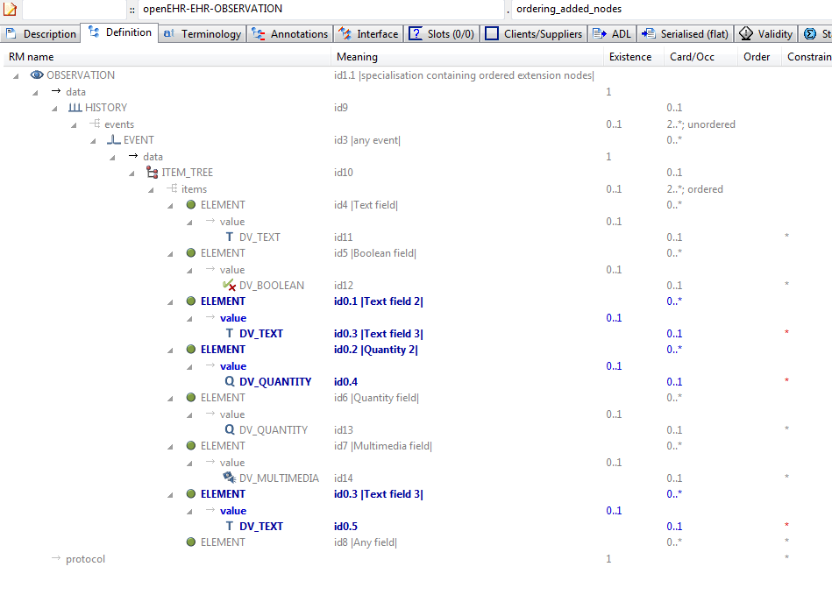

#### Ordering Added Nodes v1 AML Diagram

### Ordering Parent - Merge Children v1 Example

Example of merging child nodes into parent in a specific order.

#### Ordering Parent - Merge Children v1 ADL

OBSERVATION[id1.1] matches { -- Blood matching

/data[id2]/events[id3]/data[id4]/items matches {

ELEMENT[id10]

ELEMENT[id10.1] occurrences matches {0..1} matches { -- Rhesus

value matches {

DV\_TEXT[id0.11]

}

}

ELEMENT[id10.2] occurrences matches {0..1} matches { -- ABO

value matches {

DV\_TEXT[id0.12]

}

}

ELEMENT[id0.1] occurrences matches {0..1} matches { -- Antibodies detected

value matches {

DV\_BOOLEAN[id0.13]

}

}

before [id12]

CLUSTER[id0.2] occurrences matches {0..1} -- Antibodies

}

}

#### Ordering Parent - Merge Children v1 ADL Diagram

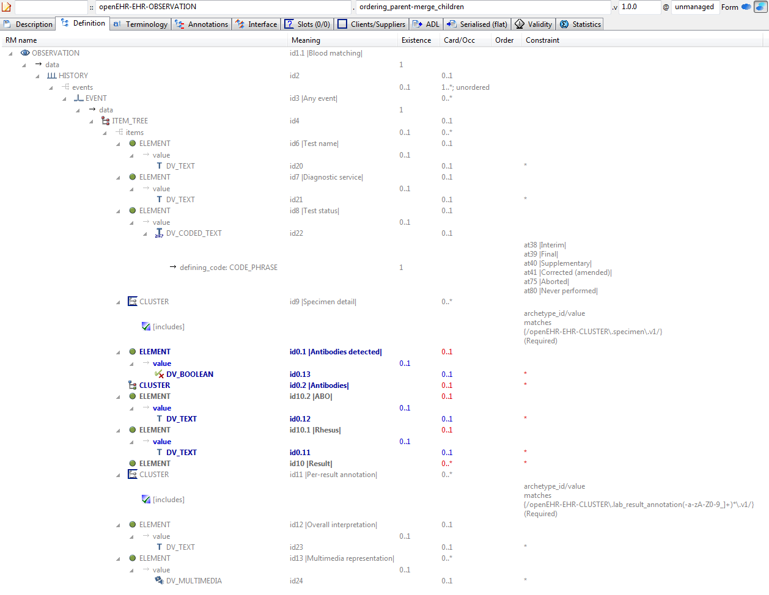

#### Ordering Parent - Merge Children v1 AML Diagram

### Ordering Parent v1 Example

Parent for child that redefines and adds nodes, marked for a certain location in flat, using 'before' keyword.

#### Ordering Parent v1 ADL

OBSERVATION[id1] matches { -- Laboratory test

data matches {

HISTORY[id2] matches {

events cardinality matches {1..\*; unordered} matches {

EVENT[id3] occurrences matches {0..\*} matches { -- Any event

data matches {

ITEM\_TREE[id4] matches {

items matches {

ELEMENT[id6] occurrences matches {0..1} matches { -- Test name

value matches {

DV\_TEXT[id20]

}

}

ELEMENT[id7] occurrences matches {0..1} matches { -- Diagnostic service

value matches {

DV\_TEXT[id21]

}

}

ELEMENT[id8] occurrences matches {0..1} matches { -- Test status

value matches {

DV\_CODED\_TEXT[id22] matches {

defining\_code matches {[ac1]} -- Test status (synthesised)

}

}

}

allow\_archetype CLUSTER[id9] occurrences matches {0..\*} matches { -- Specimen detail

include

archetype\_id/value matches {/openEHR-EHR-CLUSTER\.specimen\.v1/}

exclude

archetype\_id/value matches {/.\*/}

}

ITEM[id10] occurrences matches {0..\*} -- Result

allow\_archetype CLUSTER[id11] occurrences matches {0..\*} matches { -- Per-result annotation

include

archetype\_id/value matches {/openEHR-EHR-CLUSTER\.lab\_result\_annotation(-a-zA-Z0-9\_]+)\*\.v1/}

exclude

archetype\_id/value matches {/.\*/}

}

ELEMENT[id12] occurrences matches {0..1} matches { -- Overall interpretation

value matches {

DV\_TEXT[id23]

}

}

ELEMENT[id13] occurrences matches {0..\*} matches { -- Multimedia representation

value matches {

DV\_MULTIMEDIA[id24]

}

}

}

}

}

}

}

}

}

}

#### Ordering Parent v1 ADL Diagram

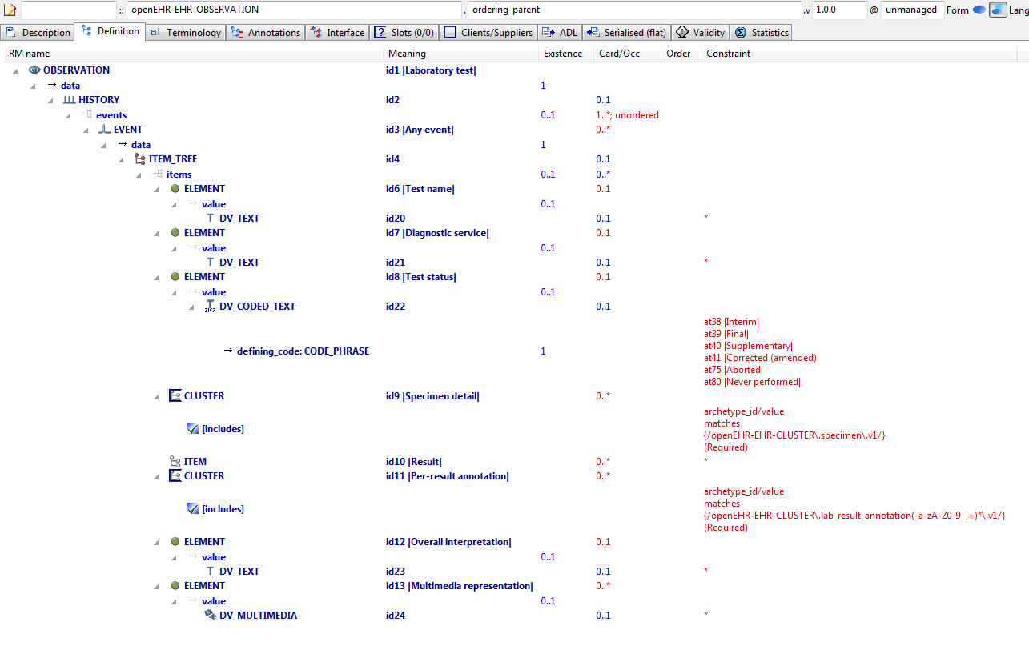

#### Ordering Parent v1 AML Diagram

### Redefine 1 Value v1 Example

Example of redefinition of a value set into a narrower subset of the original.

#### Redefine 1 Value v1 ADL

OBSERVATION[id1.1] matches { -- first level specialisation archetype

/data/events[id3]/data/items matches {

ELEMENT[id4.1] matches { -- Redefined text field

value matches {

DV\_CODED\_TEXT[id0.6] matches {

defining\_code matches {[ac0.1]} -- (added by post-parse processor)

}

}

}

}

}

#### Redefine 1 Value v1 ADL Diagram

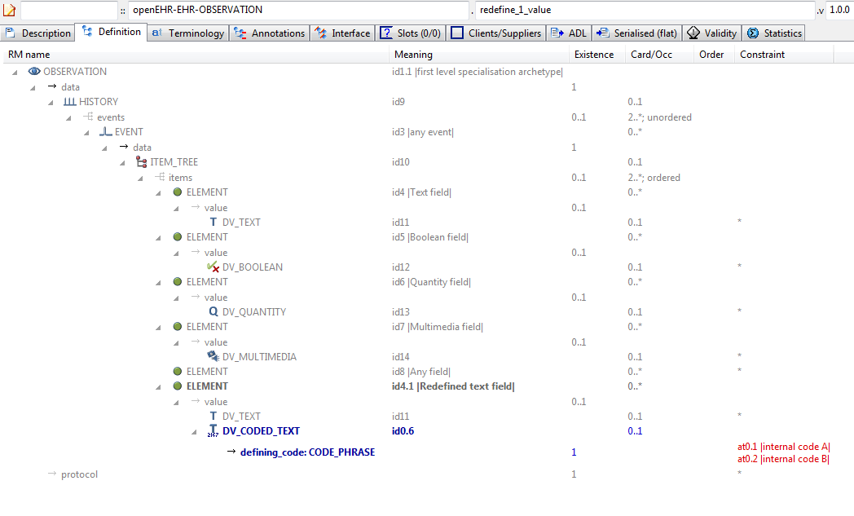

#### Redefine 1 Value v1 AML Diagram

### Redefine Cardinality v1 Example

Example showing narrowing of cardinality in specialised archetype. The narrower cardinality replaces the cardinality from the parent in the computed flat form.

#### Redefine Cardinality v1 ADL

OBSERVATION[id1.1] matches { -- specialised archetype

/data/events cardinality matches {2..8; ordered}

}

#### Redefine Cardinality v1 ADL Diagram

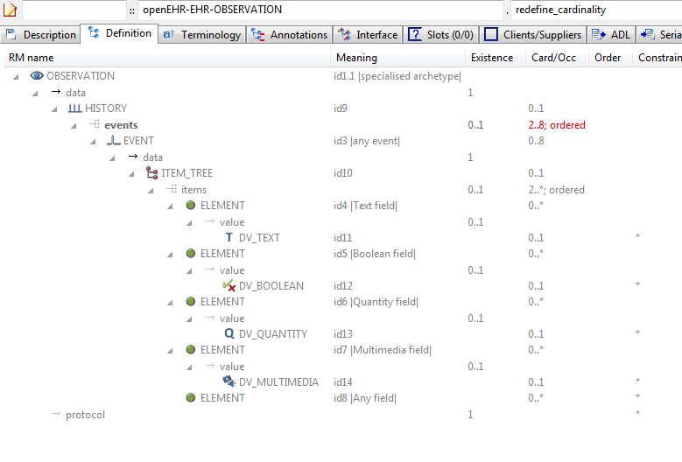

#### Redefine Cardinality v1 AML Diagram

NeuroMax:Users:patrick:git-opencimi:AML:adl-examples-for-aml:aml_diagrams:openEHR-EHR-OBSERVATION.redefine_cardinality.v1.pdf

### Redefine Node To Clones v1 Example

Example of redefinition of a single node into multiple clones. Each of the ELEMENT[id8.x] nodes is a distinct clone of the ELEMENT[id8] node from the parent archetype.

#### Redefine Node To Clones v1 ADL

OBSERVATION[id1.1] matches { -- multi-level redefinition archetype

/data/events[id3]/data/items matches {

ELEMENT[id8.1] matches { -- 1st redefine of at0007 node

value matches {

DV\_QUANTITY[id0.7]

}

}

ELEMENT[id8.2] matches { -- 2nd redefine of at0007 node

value matches {

DV\_QUANTITY[id0.8]

}

}

ELEMENT[id8.3] matches { -- 3rd redefine of at0007 node

value matches {

DV\_QUANTITY[id0.9]

}

}

}

}

#### Redefine Node To Clones v1 ADL Diagram

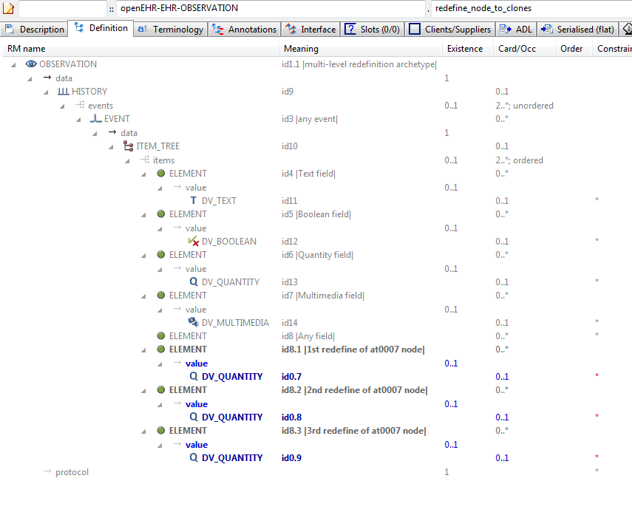

#### Redefine Node To Clones v1 AML Diagram

### Redefine Occurrences v1 Example

Example of refinement of occurrences to {0..1} from {0..\*}.

#### Redefine Occurrences v1 ADL

OBSERVATION[id1.1] matches {

/data[id9]/events matches {

EVENT[id3.1] occurrences matches {0..1}

}

}

ontology

term\_definitions = <

["en"] = <

["id1.1"] = <

text = <"specialised archetype">

description = <"">

>

["id3.1"] = <

text = <"any event - occurrences specialised">

description = <"">

>

>

>

#### Redefine Occurrences v1 ADL Diagram

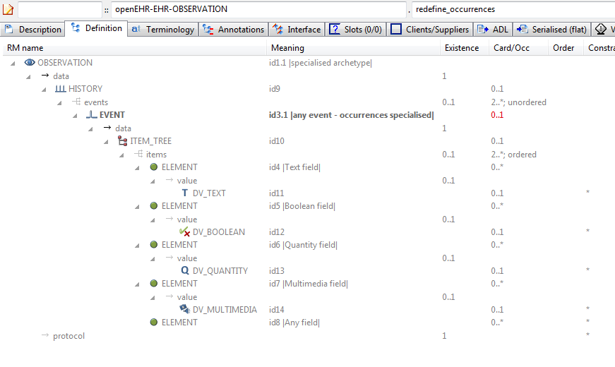

#### Redefine Occurrences v1 AML Diagram

NeuroMax:Users:patrick:git-opencimi:AML:adl-examples-for-aml:aml_diagrams:openEHR-EHR-OBSERVATION.redefine_occurrences.v1.pdf

### Spec Test Parent v1 Example

Test OBSERVATION specialisation parent archetype

#### Spec Test Parent v1 ADL

OBSERVATION[id1] matches { -- top-level archetype

data matches {

HISTORY[id9] matches {

events cardinality matches {2..\*; unordered} matches {

EVENT[id3] matches { -- any event

data matches {

ITEM\_TREE[id10] matches {

items cardinality matches {2..\*; ordered} matches {

ELEMENT[id4] matches { -- Text field

value matches {

DV\_TEXT[id11]

}

}

ELEMENT[id5] matches { -- Boolean field

value matches {

DV\_BOOLEAN[id12]

}

}

ELEMENT[id6] matches { -- Quantity field

value matches {

DV\_QUANTITY[id13]

}

}

ELEMENT[id7] matches { -- Multimedia field

value matches {

DV\_MULTIMEDIA[id14]

}

}

ELEMENT[id8] -- Any field

}

}

}

}

}

}

}

protocol existence matches {1}

}

#### Spec Test Parent v1 ADL Diagram

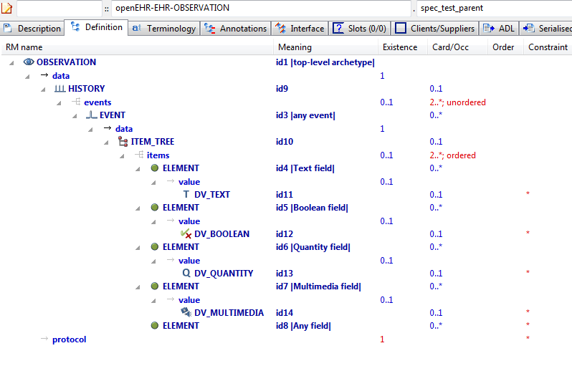

#### Spec Test Parent v1 AML Diagram

### Tuple Parent v1 Example

Example archetype containing tuple constraints for the types DV\_QUANTITY and DV\_ORDINAL.

#### Tuple Parent v1 ADL

OBSERVATION[id1] matches { -- Intravascular pressure

data matches {

HISTORY[id2] matches {

events cardinality matches {1..\*; unordered} matches {

EVENT[id3] occurrences matches {0..\*} matches { -- Any event

data matches {

ITEM\_TREE[id4] matches {

items cardinality matches {1; ordered} matches {

ELEMENT[id6] occurrences matches {0..1} matches { -- Pressure

value matches {

DV\_QUANTITY[id42] matches {

property matches {[at29]}

[magnitude, units, precision] matches {

[{|>=0.0|}, {"mm[Hg]"}, {2}],

[{|>=0.0|}, {"cm[H20]"}, {2}]

}

}

}

}

ELEMENT[id16] occurrences matches {0..1} matches { -- Ordinal

value matches {

DV\_ORDINAL[id43] matches {

[value, symbol] matches {

[{0}, {[at17]}],

[{2}, {[at18]}],

[{4}, {[at19]}],

[{6}, {[at20]}],

[{8}, {[at21]}]

}

}

}

}

}

}

}

}

}

}

}

}

#### Tuple Parent v1 ADL Diagram

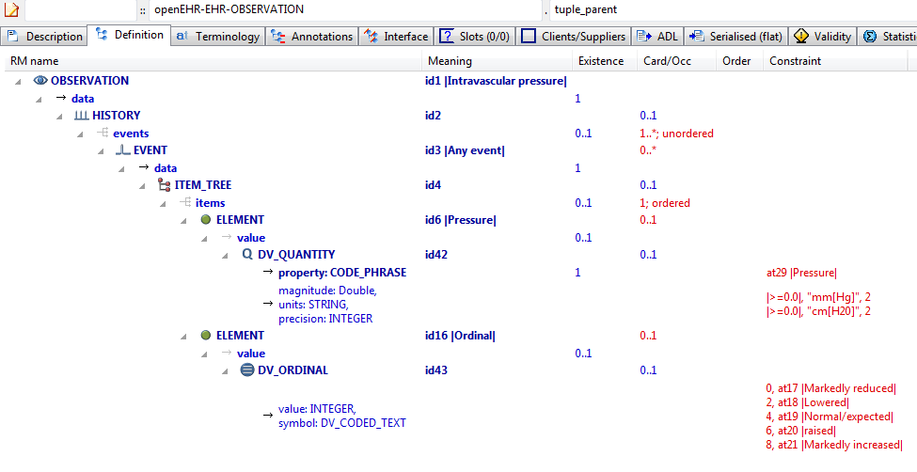

#### Tuple Parent v1 AML Diagram

### Tuple Redefine To Narrower v1 Example

Illustrate redefinition of tuple to narrower tuple.

#### Tuple Redefine To Narrower v1 ADL

OBSERVATION[id1.1] matches { -- Intravascular pressure redefined

/data[id2]/events[id3]/data[id4]/items[id16]/value matches {

DV\_ORDINAL[id43] matches {

[value, symbol] matches {

[{0}, {[at17]}],

[{6}, {[at20]}],

[{8}, {[at21]}]

}

}

}

}

#### Tuple Redefine To Narrower v1 ADL Diagram

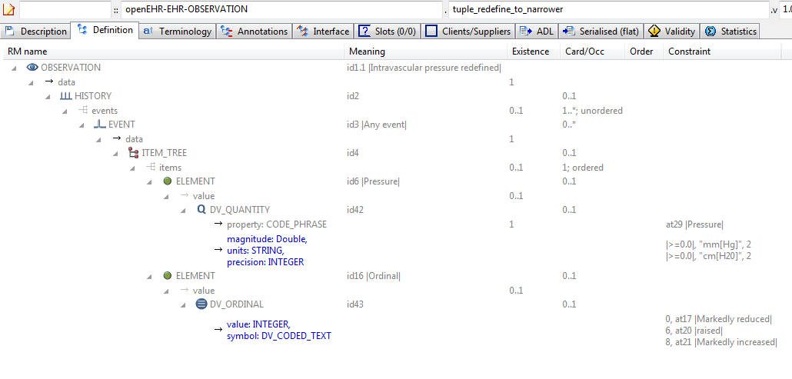

#### Tuple Redefine To Narrower v1 AML Diagram

### Tuple Redefine To Single v1 Example

Illustrate redefinition of tuple to narrower tuple consisting of one item only.

#### Tuple Redefine To Single v1 ADL

OBSERVATION[id1.1] matches { -- Intravascular pressure redefined

/data[id2]/events[id3]/data[id4]/items[id6]/value matches {

DV\_QUANTITY[id42] matches {

[magnitude, units, precision] matches {

[{|>=0.0|}, {"cm[H20]"}, {2}]

}

}

}

}

#### Tuple Redefine To Single v1 ADL Diagram

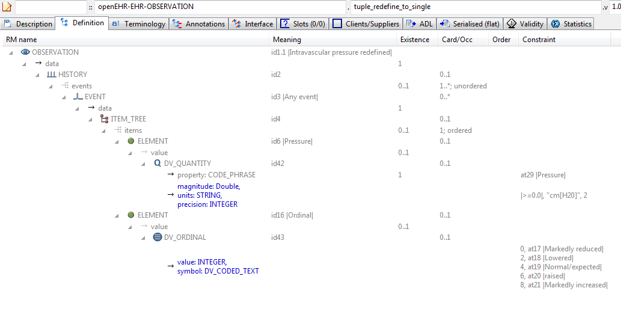

#### Tuple Redefine To Single v1 AML Diagram

NeuroMax:Users:patrick:git-opencimi:AML:adl-examples-for-aml:aml_diagrams:openEHR-EHR-OBSERVATION.tuple_redefine_to_single.v1.pdf

### Section Parent v1 Example

To provide a root heading for physical examination in all structured recordings

#### Section Parent v1 ADL

SECTION[id1] -- Physical examination

#### Section Parent v1 ADL Diagram

#### Section Parent v1 AML Diagram

## Terminology Term Bindings Examples

### Term Bindings Basic Example

Simple example of LOINC terminology bindings to id-codes. In this case, the bound terms define the meaning, i.e. say what each node 'is-about'.

#### Term Bindings Basic ADL

OBSERVATION[id1] matches { -- Apgar score

data matches {

HISTORY[id3] matches {

events cardinality matches {1..\*; unordered} matches {

POINT\_EVENT[id4] occurrences matches {0..1} matches { -- 1 minute

data matches {

ITEM\_LIST[id2] matches {

items cardinality matches {1..6; ordered} matches {

ELEMENT[id5] occurrences matches {0..1} -- Total

}

}

}

}

POINT\_EVENT[id7] occurrences matches {0..1} matches { -- 5 minute

data matches {

use\_node ITEM\_LIST[id9] /data[id3]/events[id4]/data[id2] -- /data[id3]/events[1 minute]/data[id2]

}

}

}

}

}

}

#### Term Bindings Basic ADL Diagram

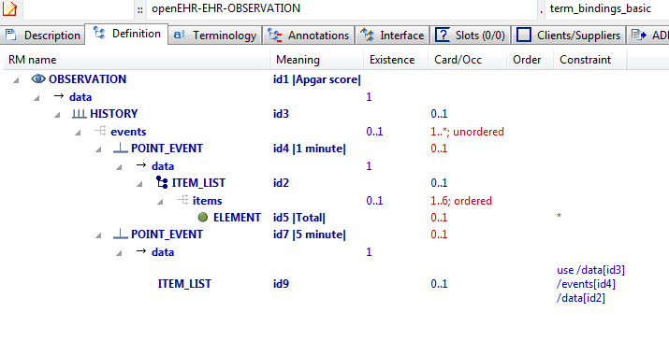

#### Term Bindings Basic AML Diagram

NeuroMax:Users:patrick:git-opencimi:AML:adl-examples-for-aml:aml_diagrams:openEHR-EHR-OBSERVATION.term_bindings_basic.pdf

### Term Bindings Paths Example

Simple example of a term binding to a path rather than a code. The meaning of this is that the binding only relates to the node at the path, whereas with a code-only binding, it relates to every location where that node appears (e.g. due to use\_node internal references) or that the code appears (due to static definition).

#### Term Bindings Paths ADL

OBSERVATION[id1] matches { -- Apgar score

data matches {

HISTORY[id3] matches {

events cardinality matches {1..\*; unordered} matches {

POINT\_EVENT[id4] occurrences matches {0..1} matches { -- 1 minute

data matches {

ITEM\_LIST[id2] matches {

items cardinality matches {1..6; ordered} matches {

ELEMENT[id5] occurrences matches {0..1} -- Total

}

}

}

}

POINT\_EVENT[id7] occurrences matches {0..1} matches { -- 5 minute

data matches {

use\_node ITEM\_LIST[id9] /data[id3]/events[id4]/data[id2] -- /data[id3]/events[1 minute]/data[id2]

}

}

}

}

}

}

#### Term Bindings Paths ADL Diagram

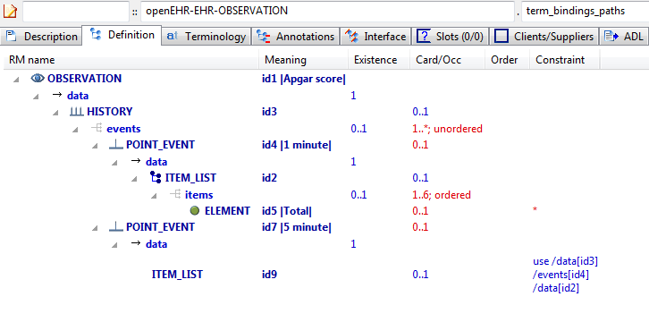

#### Term Bindings Paths AML Diagram

NeuroMax:Users:patrick:git-opencimi:AML:adl-examples-for-aml:aml_diagrams:openEHR-EHR-OBSERVATION.term_bindings_paths.pdf

### Term Bindings Paths Use Refs v1 Example

Example of bindings to paths that traverse use\_node references, i.e. paths that are computed when taking a use\_node internal reference into account.

#### Term Bindings Paths Use Refs v1 ADL

OBSERVATION[id1] matches { -- Apgar score

data matches {

HISTORY[id3] matches {

events cardinality matches {1..\*; unordered} matches {

POINT\_EVENT[id4] occurrences matches {0..1} matches { -- 1 minute

offset matches {

DV\_DURATION[id46] matches {

value matches {PT1M}

}

}

data matches {

ITEM\_LIST[id2] matches {

items cardinality matches {1..6; ordered} matches {

ELEMENT[id10] occurrences matches {0..1} matches { -- Respiratory effort

value matches {

DV\_ORDINAL[id47] matches {

[value, symbol] matches {

[{0}, {[at11]}],

[{1}, {[at12]}],

[{2}, {[at13]}]

}

}

}

}

ELEMENT[id6] occurrences matches {0..1} matches { -- Heart Rate

value matches {

DV\_ORDINAL[id48] matches {

[value, symbol] matches {

[{0}, {[at7]}],

[{1}, {[at8]}],

[{2}, {[at9]}]

}

}

}

}

ELEMENT[id14] occurrences matches {0..1} matches { -- Muscle tone

value matches {

DV\_ORDINAL[id49] matches {

[value, symbol] matches {

[{0}, {[at15]}],

[{1}, {[at16]}],

[{2}, {[at17]}]

}

}

}

}

ELEMENT[id18] occurrences matches {0..1} matches { -- Reflex irritability

value matches {

DV\_ORDINAL[id50] matches {

[value, symbol] matches {

[{0}, {[at19]}],

[{1}, {[at20]}],

[{2}, {[at21]}]

}

}

}

}

ELEMENT[id22] occurrences matches {0..1} matches { -- Skin colour

value matches {

DV\_ORDINAL[id51] matches {

[value, symbol] matches {

[{0}, {[at23]}],

[{1}, {[at24]}],

[{2}, {[at25]}]

}

}

}

}

ELEMENT[id26] occurrences matches {0..1} matches { -- Total

value matches {

DV\_COUNT[id52] matches {

magnitude matches {|0..10|}

}

}

}

}

}

}

}

POINT\_EVENT[id27] occurrences matches {0..1} matches { -- 2 minute

offset matches {

DV\_DURATION[id53] matches {

value matches {PT2M}

}

}

data matches {

use\_node ITEM\_LIST[id41] /data[id3]/events[id4]/data[id2] -- /data[id3]/events[1 minute]/data[id2]

}

}

POINT\_EVENT[id28] occurrences matches {0..1} matches { -- 3 minute

offset matches {

DV\_DURATION[id54] matches {

value matches {PT3M}

}

}

data matches {

use\_node ITEM\_LIST[id42] /data[id3]/events[id4]/data[id2] -- /data[id3]/events[1 minute]/data[id2]

}

}

POINT\_EVENT[id29] occurrences matches {0..1} matches { -- 5 minute

offset matches {

DV\_DURATION[id55] matches {

value matches {PT5M}

}

}

data matches {

use\_node ITEM\_LIST[id43] /data[id3]/events[id4]/data[id2] -- /data[id3]/events[1 minute]/data[id2]

}

}

POINT\_EVENT[id32] occurrences matches {0..1} matches { -- 10 minute

offset matches {

DV\_DURATION[id56] matches {

value matches {PT10M}

}

}

data matches {

use\_node ITEM\_LIST[id44] /data[id3]/events[id4]/data[id2] -- /data[id3]/events[1 minute]/data[id2]

}

}

EVENT[id38] occurrences matches {0..\*} matches { -- Any event

data matches {

use\_node ITEM\_LIST[id45] /data[id3]/events[id4]/data[id2] -- /data[id3]/events[1 minute]/data[id2]

}

}

}

}

}

protocol matches {

ITEM\_LIST[id30] matches {

items matches {

ELEMENT[id31] occurrences matches {0..1} matches { -- Notes on measurement

value matches {

DV\_TEXT[id57]

}

}

}

}

}

}

#### Term Bindings Paths Use Refs v1 ADL Diagram

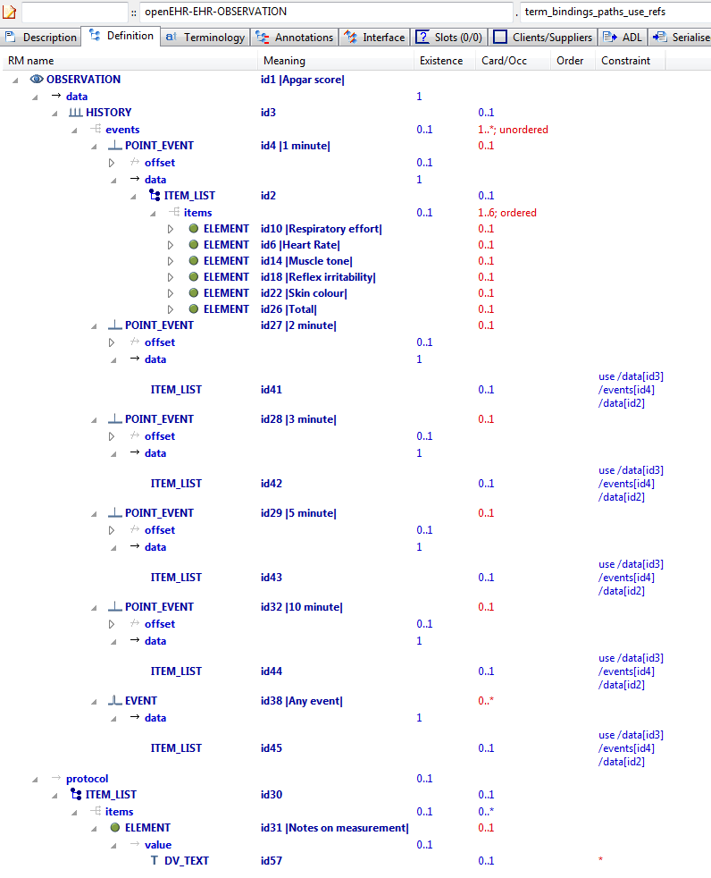

#### Term Bindings Paths Use Refs v1 AML Diagram

### Value Set Binding v1 Example

Example of bindings to value sets (signified by ac codes) rather than individual codes.

#### Value Set Binding v1 ADL

OBSERVATION[id1] matches { -- Cough - ZN

data matches {

HISTORY[id2] matches {

events cardinality matches {1..\*; unordered} matches {

EVENT[id3] occurrences matches {0..1} matches { -- Any event

data matches {

ITEM\_TREE[id4] matches {

items matches {

ELEMENT[id5] occurrences matches {0..1} matches { -- Character

value matches {

DV\_CODED\_TEXT[id6] matches {

defining\_code matches {[ac2]} -- MZN-SIF-Dihanje-Kašelj

}

}

}

}

}

}

}

}

}

}

}

#### Value Set Binding v1 ADL Diagram

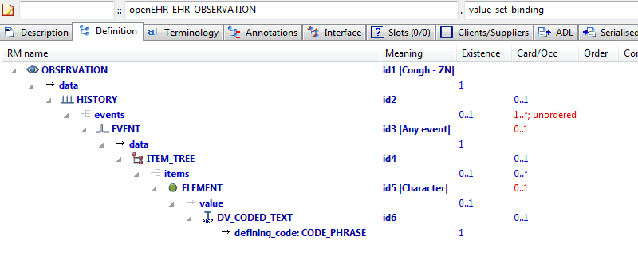

#### Value Set Binding v1 AML Diagram

### Value Set Binding Snomed v1 Example

Demonstrate constraint binding of individual terms to multiple terminologies, using URI references.

#### Value Set Binding Snomed v1 ADL

OBSERVATION[id1] matches { -- Pulse

data matches {

HISTORY[id3] matches {

events cardinality matches {1..\*; unordered} matches {

EVENT[id4] occurrences matches {0..\*} matches { -- Any event

data matches {

ITEM\_TREE[id2] matches {

items matches {

ELEMENT[id1006] occurrences matches {0..1} matches { -- Pulse Presence

value matches {

DV\_CODED\_TEXT[id1039] matches {

defining\_code matches {[ac1]} -- Pulse Presence (synthesised)

}

}

}

ELEMENT[id5] occurrences matches {0..1} matches { -- Rate

name matches {

DV\_CODED\_TEXT[id1040] matches {

defining\_code matches {[ac2]} -- Rate (synthesised)

}

}

value matches {

DV\_QUANTITY[id1041] matches {

property matches {[at1046]}

magnitude matches {|>=0.0|}

precision matches {0}

units matches {"/min"}

}

}

}

ELEMENT[id6] occurrences matches {0..1} matches { -- Regularity

value matches {

DV\_CODED\_TEXT[id1042] matches {

defining\_code matches {[ac3]} -- Regularity (synthesised)

}

}

}

ELEMENT[id1031] occurrences matches {0..\*} matches { -- Character

value matches {

DV\_TEXT[id1043]

}

}

ELEMENT[id1023] occurrences matches {0..1} matches { -- Clinical Description

value matches {

DV\_TEXT[id1044]

}

}

ELEMENT[id1024] occurrences matches {0..\*} matches { -- Clinical Interpretation

value matches {

DV\_TEXT[id1045]

}

}

}

}

}

state matches {

ITEM\_TREE[id13] matches {

items matches {

ELEMENT[id14] occurrences matches {0..1} matches { -- Position

value matches {

DV\_CODED\_TEXT[id1046] matches {

defining\_code matches {[ac4; at1002]} -- Position (synthesised)

}

}

}

ELEMENT[id1019] occurrences matches {0..1} matches { -- Confounding Factors

value matches {

DV\_TEXT[id1047]

}

}

allow\_archetype CLUSTER[id1018] occurrences matches {0..\*} matches { -- Exertion

include

archetype\_id/value matches {/openEHR-EHR-CLUSTER\.level\_of\_exertion(-a-zA-Z0-9\_]+)\*\.v1/}

}

}

}

}

}

INTERVAL\_EVENT[id1037] occurrences matches {0..1} matches { -- Maximum

math\_function matches {

DV\_CODED\_TEXT[id1048] matches {

defining\_code matches {[at1047]}

}

}

data matches {

use\_node ITEM\_TREE[id1049] /data[id3]/events[id4]/data[id2] -- /data[id3]/events[Any event]/data[id2]

}

state matches {

use\_node ITEM\_TREE[id1050] /data[id3]/events[id4]/state[id13] -- /data[id3]/events[Any event]/state[id13]

}

}

}

}

}

}

#### Value Set Binding Snomed v1 ADL Diagram

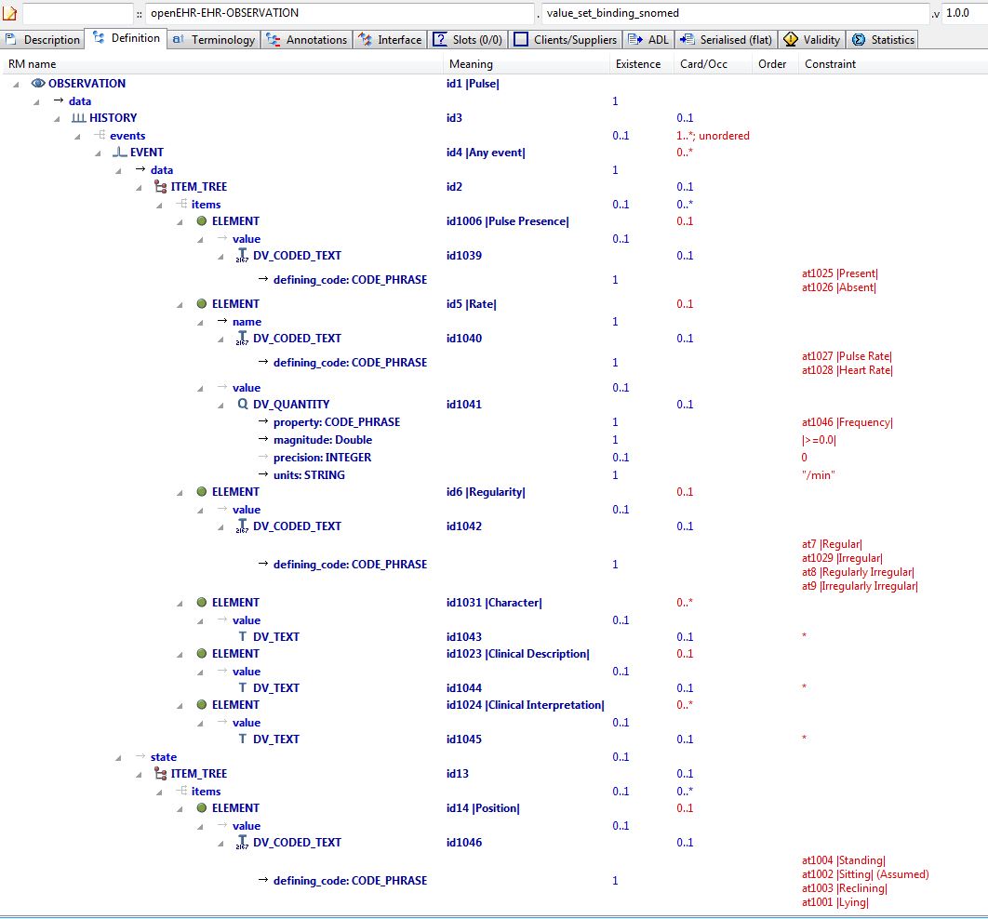

#### Value Set Binding Snomed v1 AML Diagram

## Terminology Value\_sets Examples

### External Value Set v1 Example

Example of rewriting of external value set, designated by ac-code in an ADL 1.4 archetype, to an ADL 2.0 value set.

#### External Value Set v1 ADL

OBSERVATION[id1] matches { -- Test Obs

protocol matches {

ITEM\_TREE[id2] matches {

items matches {

ELEMENT[id3] occurrences matches {0..1} matches { -- document state

value matches {

DV\_CODED\_TEXT[id4] matches {

defining\_code matches {[ac1; at1]} -- document state

}

}

}

}

}

}

}

#### External Value Set v1 ADL Diagram

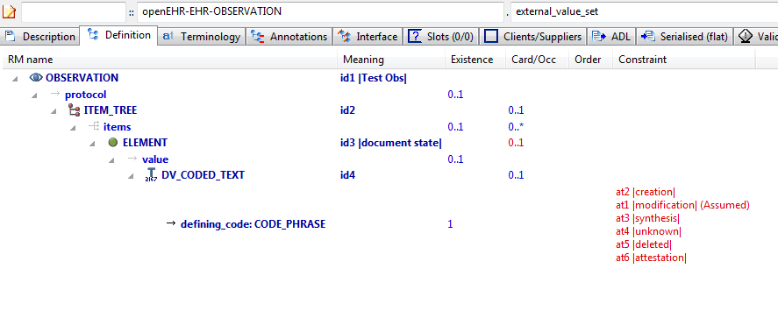

#### External Value Set v1 AML Diagram

NeuroMax:Users:patrick:git-opencimi:AML:adl-examples-for-aml:aml_diagrams:openEHR-EHR-OBSERVATION.external_value_set.v1.pdf

### Internal Value Set v1 Example

Example of rewriting of internal value set, designated by a series of at-codes in an ADL 1.4 archetype, to an ADL 2.0 value set.

#### Internal Value Set v1 ADL

OBSERVATION[id1] matches { -- Blood Pressure

data matches {

HISTORY[id2] matches { -- history

events cardinality matches {1..\*; unordered} matches {

EVENT[id7] occurrences matches {0..\*} matches { -- any event

state matches {

ITEM\_TREE[id8] matches {

items matches {

ELEMENT[id9] occurrences matches {0..1} matches { -- Position

value matches {

DV\_CODED\_TEXT[id1045] matches {

defining\_code matches {[ac1; at1002]} -- Position

}

}

}

ELEMENT[id1044] occurrences matches {0..1} matches { -- Sleep status

value matches {

DV\_CODED\_TEXT[id1046] matches {

defining\_code matches {[ac2; at1045]} -- Sleep status

}

}

}

}

}

}

}

}

}

}

protocol matches {

ITEM\_TREE[id12] matches { -- list structure

items matches {

ELEMENT[id14] occurrences matches {0..1} matches { -- Cuff size

value matches {

DV\_CODED\_TEXT[id1047] matches {

defining\_code matches {[ac3]} -- Cuff size

}

}

}

CLUSTER[id1034] occurrences matches {0..1} matches { -- Location

items matches {

ELEMENT[id15] occurrences matches {0..1} matches { -- Location of measurement

value matches {

DV\_CODED\_TEXT[id1048] matches {

defining\_code matches {[ac4]} -- Location of measurement

}

}

}

ELEMENT[id1035] occurrences matches {0..1} matches { -- Specific location

value matches {

DV\_TEXT[id1049]

}

}

}

}

ELEMENT[id1036] occurrences matches {0..1} matches { -- Method

value matches {

DV\_CODED\_TEXT[id1050] matches {

defining\_code matches {[ac5]} -- Method

}

}

}

ELEMENT[id1039] occurrences matches {0..1} matches { -- Mean Arterial Pressure Formula

value matches {

DV\_TEXT[id1051]

}

}

ELEMENT[id1011] occurrences matches {0..1} matches { -- Diastolic endpoint

value matches {

DV\_CODED\_TEXT[id1052] matches {

defining\_code matches {[ac6]} -- Diastolic endpoint

}

}

}

}

}

}

}

#### Internal Value Set v1 ADL Diagram

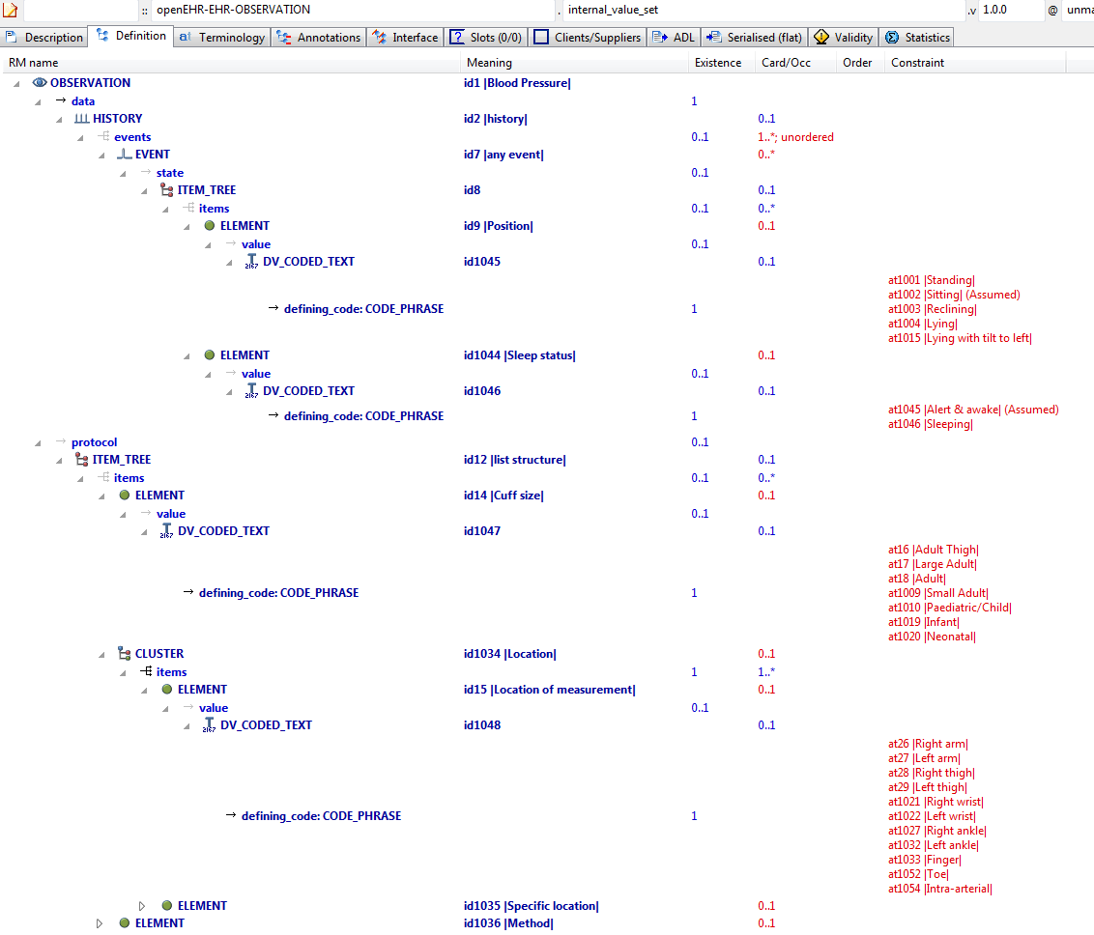

#### Internal Value Set v1 AML Diagram